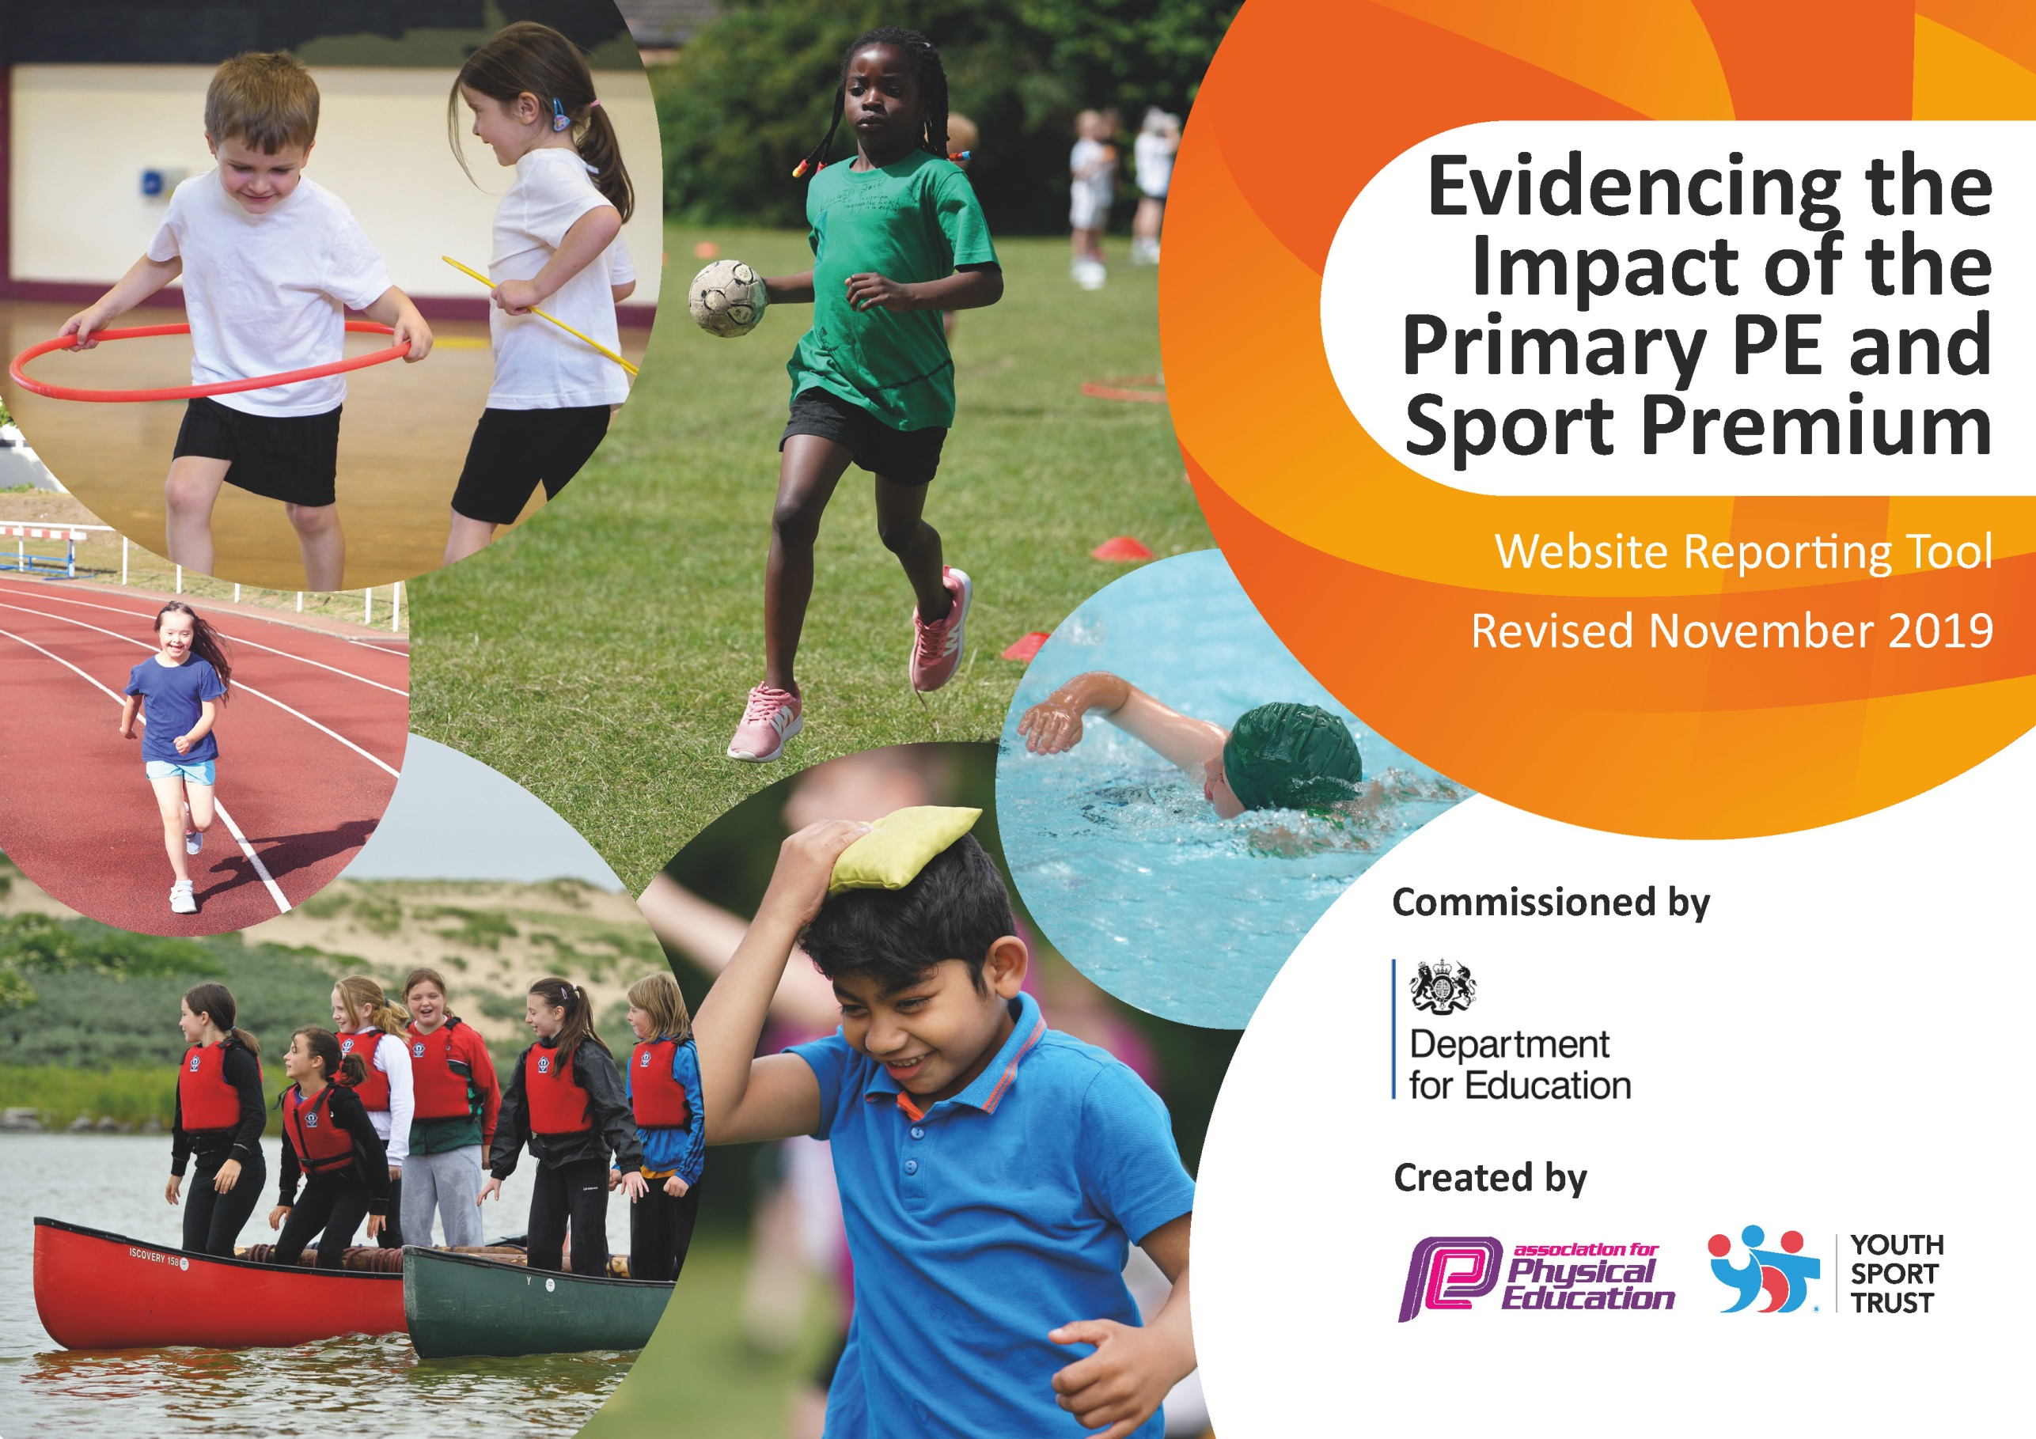
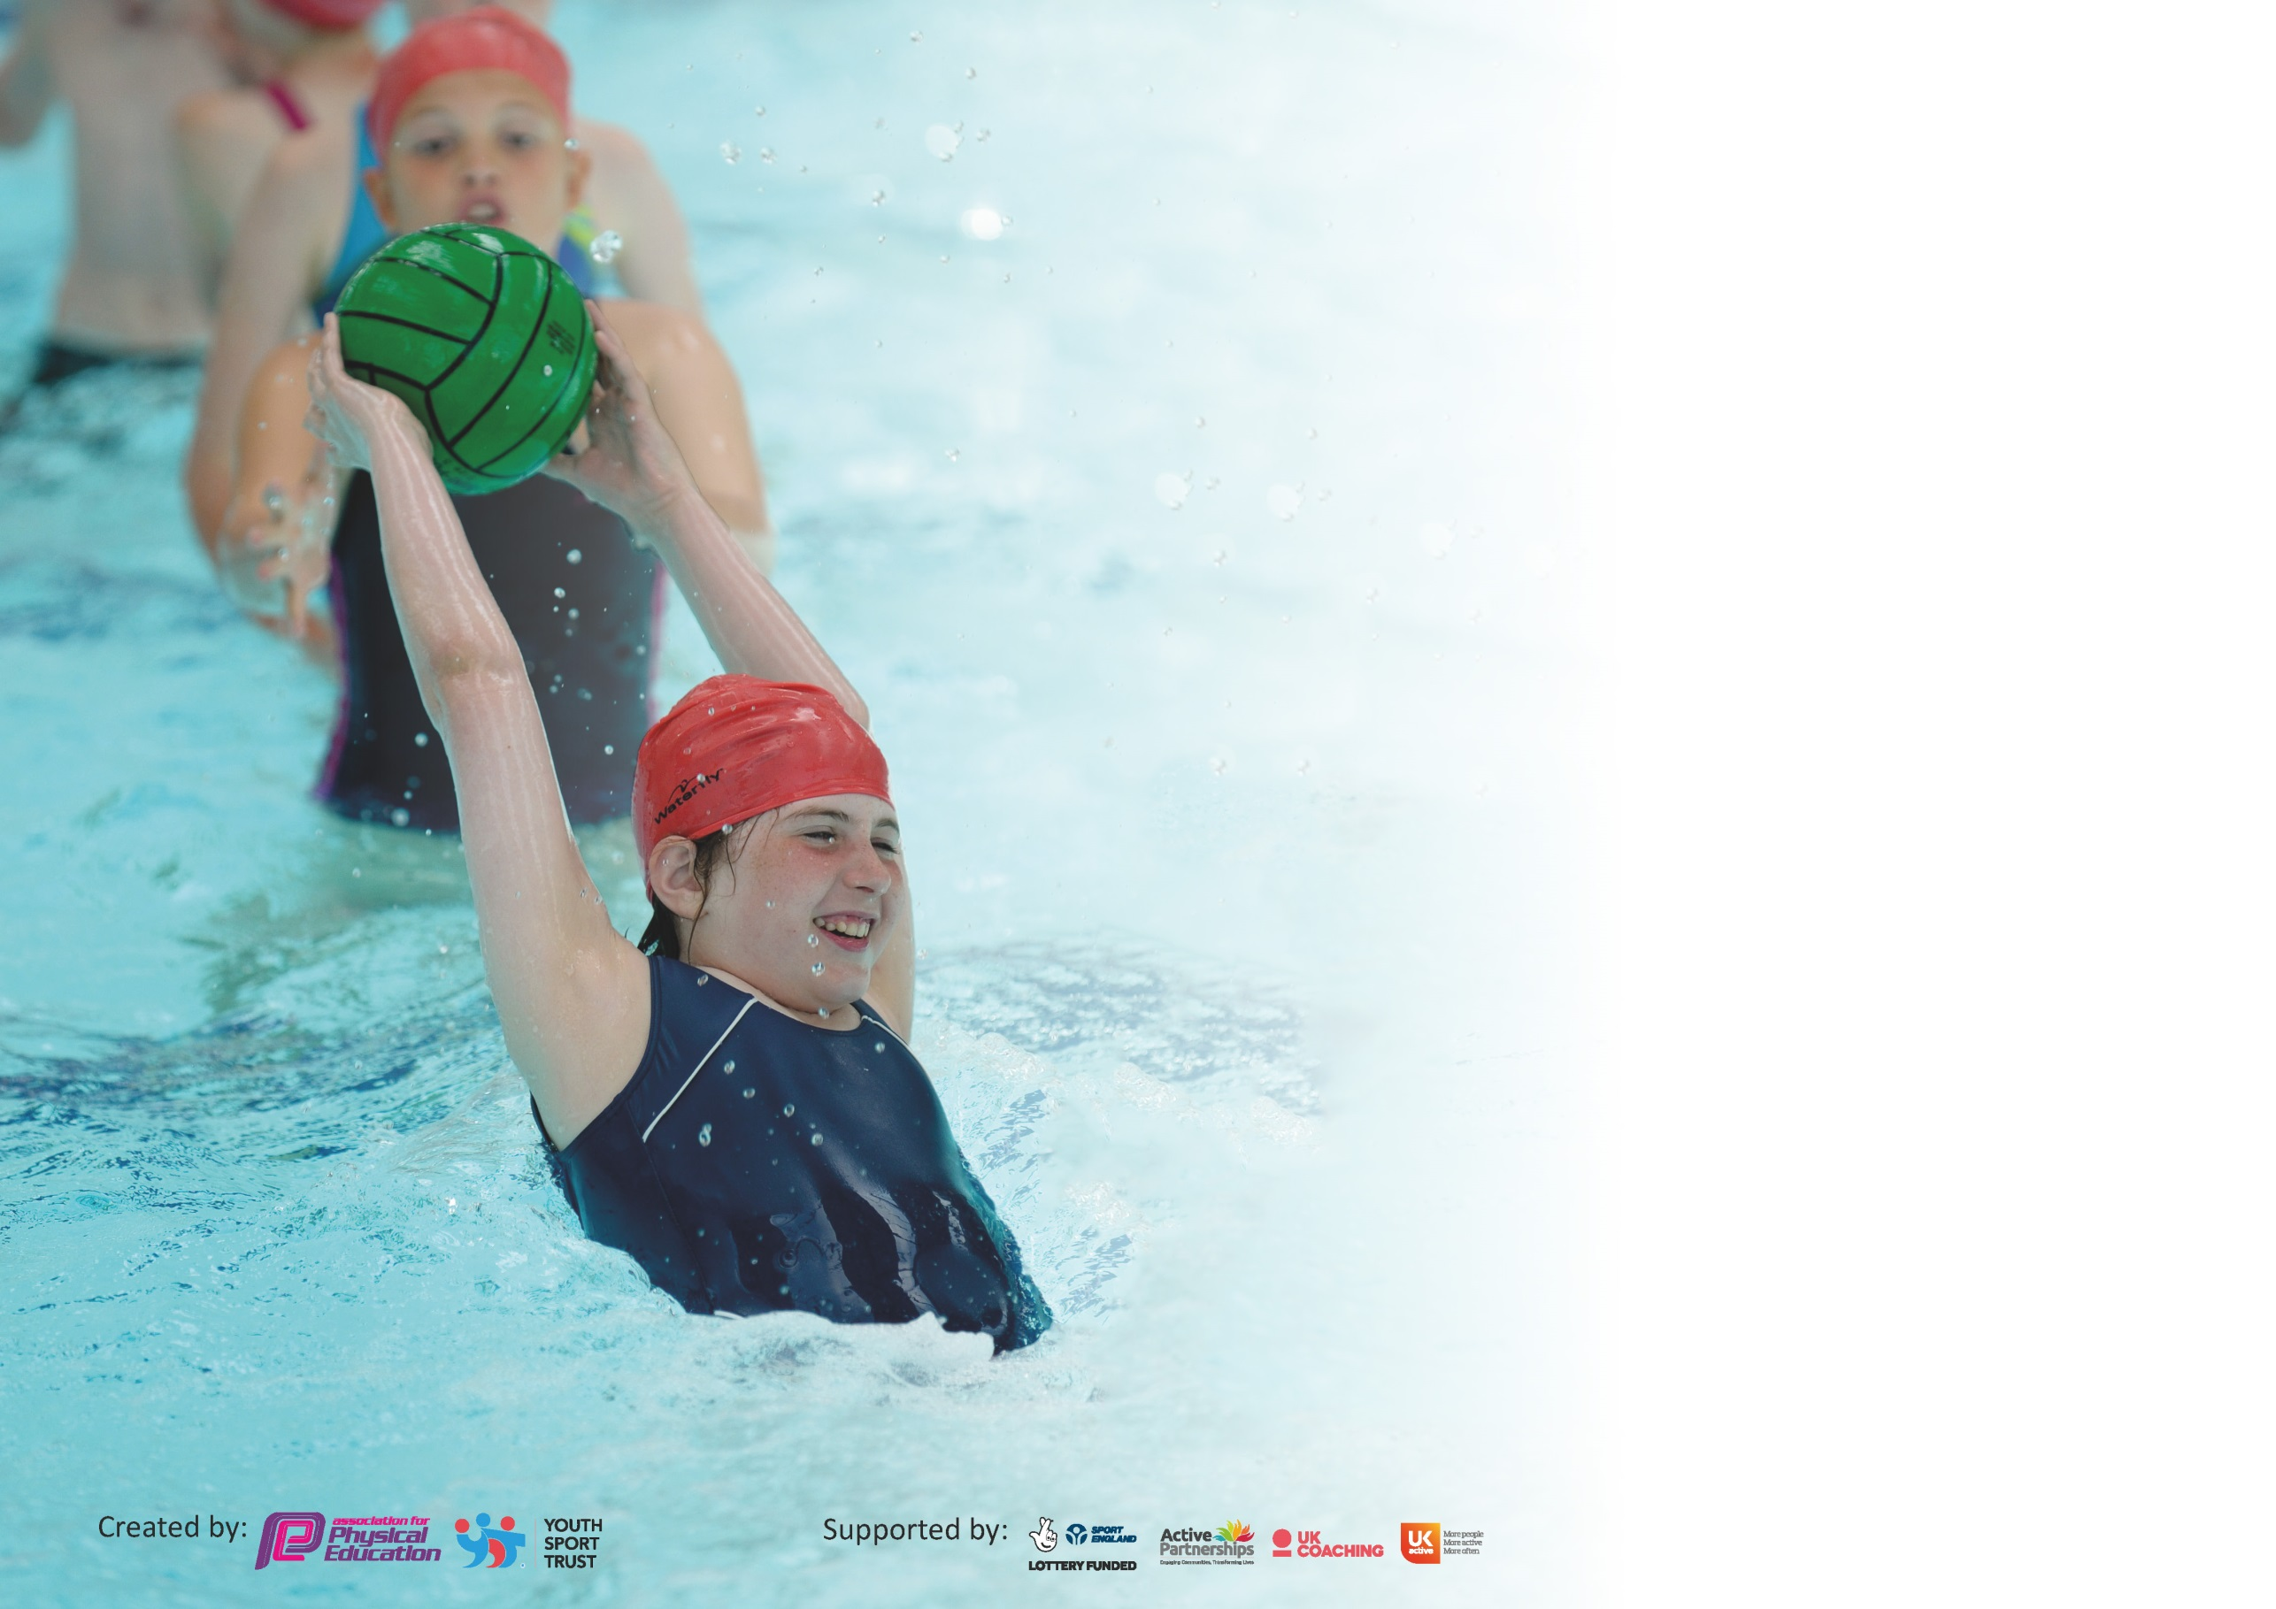

It is important that your grant is used effectively and based on school need. The Education Inspection Framework (Ofsted 2019 p64) makes clear there will be a focus on ‘whether leaders and those responsible for governors all understand their respective roles and perform these in a way that enhances the effectiveness of the school’.

Under the Quality of Education criteria (p41) inspectors consider the extent to which schools can articulate their curriculum (INTENT), construct their curriculum (IMPLEMENTATION) and demonstrate the outcomes which result (IMPACT).

To assist schools with common transferable language this template has been developed to utilise the same three headings which should make your plans easily transferable between working documents.

Schools must use the funding to make additional and sustainable improvements to the quality of Physical Education, School Sport and Physical Activity (PESSPA) they offer. This means that you should
use the Primary PE and Sport Premium to:

- Develop or add to the PESSPA activities that your school already offer
- Build capacity and capability within the school to ensure that improvements made now will benefit pupils joining the school in future years

Please visit gov.uk for the revised DfE guidance including the 5 key indicators across which schools should demonstrate an improvement. This document will help you to review your provision and to report your spend. DfE encourages schools to use this template as an effective way of meeting the reporting requirements of the Primary PE and Sport Premium.

We recommend you start by reflecting on the impact of current provision and reviewing the previous spend.

Schools are required to publish details of how they spend this funding as well as on the impact it has on pupils’ PE and sport participation and attainment by the end of the summer term or by 31st July 2020 at the latest.

We recommend regularly updating the table and publishing it on your website throughout the year. This evidences your ongoing self-evaluation of how you are using the funding to secure maximum, sustainable impact. Final copy must be posted on your website by the end of the academic year and no later than the 31st July 2020. To see an example of how to complete the table please click HERE.

Support for review and reflection - considering the 5 key indicators from DfE, what development needs are a priority for your setting and your pupils now and why? Use the space below to reflect on previous spend and key achievements and areas for development.

Key achievements to date until July 2019: | Areas for further improvement and baseline evidence of need:
Participation in sports competitions within the locality  Additional sporting opportunities offered to children after school and at lunchtimes through links with external organisations  Training for staff to increase confidence and knowledge in delivering high quality PE lessons  Investment in equipment to support all areas of the PE curriculum and ensure lessons are resourced adequately | Increase in outdoor physical activity provision during lunchtimes and breaktimes to encourage active breaks – suggestions from student council are around music to support dancing, improved use of the ball court area and more equipment available.  Increase links with Eat Smart Sheffield to work towards Healthy Schools and Food for Life Awards. Children’s understanding of how to keep healthy and their lifestyles currently are not supportive of healthy living.  Training for student PE and Physical Activity Leaders who have designated equipment and focus on leading physically active games for pupils to play at break and lunch – providing children with areas of responsibility and leadership opportunities which are missing from their lives.  Further upskilling of staff to ensure quality PE lessons across the range of skills.  Further investment in PE equipment so that lessons are effective – student council requested more equipment so they can all join in lessons together.  Taster sessions in a range of wider sports that school can’t offer to open up further opportunities for children to take part in sport.  Development of after school clubs as there is very little in the area for children to access locally.

Meeting national curriculum requirements for swimming and water safety.
What percentage of your current Year 6 cohort swim competently, confidently and proficiently over a distance of at least 25 metres?  N.B. Even though your pupils may swim in another year please report on their attainment on leaving  primary school at the end of the summer term 2020. | 43.48%
What percentage of your current Year 6 cohort use a range of strokes effectively [for example, front crawl, backstroke and breaststroke]? | 43.48%
What percentage of your current Year 6 cohort perform safe self-rescue in different water-based situations? | 100%
Schools can choose to use the Primary PE and Sport Premium to provide additional provision for swimming but this must be for activity over and above the national curriculum requirements. Have you used it in this way? | No

Action Plan and Budget Tracking
Capture your intended annual spend against the 5 key indicators. Clarify the success criteria and evidence of impact that you intend to measure to evaluate for pupils today and for the future.

Academic Year: 2019/20 | Total fund allocated: £18,240 | Date Updated: July 2020
Key indicator 1: The engagement of all pupils in regular physical activity – Chief Medical Officer guidelines recommend that primary school pupils undertake at least 30 minutes of physical activity a day in school |  |  |  | Percentage of total allocation:
 |  |  |  | 65%
Intent | Implementation |  | Impact
Your school focus should be clear what you want the pupils to know and be able to do and about  what they need to learn and to  consolidate through practice: | Make sure your actions to achieve are linked to your intentions: | Funding allocated: | Evidence of impact: what do pupils now know and what can they now do? What has changed?: | Sustainability and suggested next steps:
To increase physical activity at lunchtimes and breaktime.  To increase physical activity in the classroom/non PE lessons.  To increase the gross motor skills of our youngest children  To further develop the fixed play equipment in the playground to encourage safe, active participation at breaktimes. | Addition of sound system for use at break and lunch.  Investment in new resources for ‘play-shed’  Purchase of iMoves resources including a range of active lesson resources and home learning resources to promote physical activity. Investment in blenders, nutrition learning from Eat Sheffield and SUFC  Purchase of fixed climbing/physical equipment for the outdoor area in EYFS  Improving access to games in the shared social areas. This includes the re-lining of the ball court area to improve games at social times. The improvement of the basketball facilities including nets, back boards and increasing the height of the surrounding fencing.  Development of new markings for playground games in different areas to encourage social games | £1000  £495  £4700  £3450  £2200 | Pupils have shown an increase in physical activity at break and lunchtimes when music is played. This includes dancing, and a general increase in physically active games.  Pupils have really enjoyed the new resources at break and lunch time, in particular the swing balls.  SUFC and nutrition learning postponed due to lockdown  Not able to purchase and have fitted due to lockdown  Not able to purchase and complete due to lockdown  Not completed due to lockdown | Meeting with school council to decide on further investments for Play Pod.  Need to fix swing balls as some are broken.  Invest in a school skipping day. Many providers can offer this.  Purchase and installation of EYFS play equipment needed  Further development of the fixed playground opportunities to encourage participation at breaktimes.  Creation of a new bike area at the playground gate so easy access and encouraging children to walk/bike/scoot to school
Key indicator 2: The profile of PESSPA being raised across the school as a tool for whole school improvement |  |  |  | Percentage of total allocation:
 |  |  |  | 24%
Intent | Implementation |  | Impact
Your school focus should be clear what you want the pupils to know and be able to do and about  what they need to learn and to  consolidate through practice: | Make sure your actions to achieve are linked to your intentions: | Funding allocated: | Evidence of impact: what do pupils now know and what can they now do? What has changed?: | Sustainability and suggested next steps:
Improve access children have to high quality resources for PESSPA.  . | Investment in new handball introductory kit with activity cards for teachers/pupils to use.  Investment in 2x new netball sets.  New ball pumps  Imoves membership.  Membership of FSSP – access to training, sporting opportunities, extra curricular clubs  Training for break/lunch time sport and physical activity student leaders.  Increasing quality and quantity of equipment for PE sessions to enable high quality learning.  Provision of additional equipment to support intra school competitions | £133  £120  £20  As seen in Ki1.  £2,250  £400  £1000  £465 | Children have loved using the new handball kits and have shown increased awareness and skill in invasion and team games.  Many of the purchases have happened during lockdown and thus the impact is yet to be seen, but we are very confident it will lead to increased quality of PE lessons, and increased enjoyment of PESSPA in school.  Unable to fulfil the training for student leaders due to lockdown restrictions | Training required for MDS and student leaders  Monitoring of the use of equipment and establishing systems for replacing worn out items.  Additional swimming sessions due to missed opportunities during lockdown and low % of swimmers

Key indicator 3: Increased confidence, knowledge and skills of all staff in teaching PE and sport |  |  |  | Percentage of total allocation:
 |  |  |  | 5%
Intent | Implementation |  | Impact
Your school focus should be clear | Make sure your actions to | Funding | Evidence of impact: what do | Sustainability and suggested
what you want the pupils to know | achieve are linked to your | allocated: | pupils now know and what | next steps:
and be able to do and about | intentions: |  | can they now do? What has
what they need to learn and to |  |  | changed?:
consolidate through practice:
Increase the confidence of teaching staff to teach high quality PE with a high level of activity, and to help staff provide physical activity to children throughout the day. | Staff CPD session led by LC and KJ (PE Leads). This focused on a number of issues staff had highlighted as wanting to increase their confidence in, in particular safe use of gymnastics equipment in the hall.  Specialist coaches leading PE sessions to model to staff effective lessons in a range of sports/games  Tagtiv8 staff CPD session focused on developing physically active learning within the curriculum.  Release of a staff member to support in PE for early years  iMoves resources  Curriculum support from Forge Partnership to develop sustainable teacher skills in P.E. including running in house after school clubs. | Free  £500  Free  £400  As in Ki1 | Staff commented that it was one of the most useful CPD/staff meetings and that they came away with many new ideas they can implement immediately in PE and in physically active learning throughout the day. Staff also became more aware of physical activity expectations, and diet and obesity issues. Specialist coaches unable to come in due to lockdown  Staff also commented that they are now much more confident in using the gymnastics equipment in the hall safely, including the wall bars.  Unable to fulfil the training for EYFS staff due to lockdown restrictions  CPD support provided but cut short due to lockdown. After school clubs not able to run. | A staff CPD session in Autumn Term 1 focused on PE and Promoting Physical Activity in School post C19 Lockdown. In particular, focus on teaching games children can play at break time that do not require much/any physical contact for all staff  Curriculum support for staff from modelled high quality lessons delivered by specialist coaches.
Key indicator 4: Broader experience of a range of sports and activities offered to all pupils |  |  |  | Percentage of total allocation:
 |  |  |  | 3%
Intent | Implementation |  | Impact
Your school focus should be clear | Make sure your actions to | Funding | Evidence of impact: what do | Sustainability and suggested
what you want the pupils to know | achieve are linked to your | allocated: | pupils now know and what | next steps:
and be able to do and about | intentions: |  | can they now do? What has
what they need to learn and to |  |  | changed?:
consolidate through practice:
Provide a wide range of new sporting experiences for children to engage with, whilst promoting community links to support parents/students to find clubs for students to engage with. We have given a particular focus to martial arts as it helps children to develop their self-confidence and self-control. | Y6 Judo for first half term of Autumn term. This was provided by an excellent coach (Andy Parsons) who runs a local Judo club (Manor Top). Leaflets with the offer a free first session for children were provided.  Handball introductory kit  Karate instructors from Graves Health and Sports Centre came in and provided a karate taster day for children in Y1-Y5.  A coach was due to attend school for a Taekwondo taster day for y1-y6 but this had to be cancelled due to C19 lockdown.  Tagtiv8 activity day. | £525  As in Ki2  Free  Free  Grant sourced from Royal Institute. | A number of Y6 students have since attended the Judo club at Manor Top.  A number of students have begun attending martial arts (Judo, Karate, Taekwondo) clubs at Graves Health and Sports Centre and other local centres. The increase in links with local community clubs has helped | If possible arrange for martial arts clubs for a number of year groups from autumn term. Dependent on C19.  Look into other sports or physical activity that could be introduced to the children to widen their experiences

Key indicator 5: Increased participation in competitive sport |  |  |  | Percentage of total allocation:
 |  |  |  | 3%
Intent | Implementation |  | Impact
Your school focus should be clear | Make sure your actions to | Funding | Evidence of impact: what do | Sustainability and suggested
what you want the pupils to know | achieve are linked to your | allocated: | pupils now know and what | next steps:
and be able to do and about | intentions: |  | can they now do? What has
what they need to learn and to |  |  | changed?:
consolidate through practice:
To increase the participation in competitive sport of those children highlighted as otherwise not having the opportunity (i.e. outside of school). | Sheffield FC after school football club.  Martial arts clubs joined.  School sports competitions planned for summer term but cancelled due to C19.  Online School Games competition during lockdown. | £400  £200 travel costs | We had many competitions planned for the summer term but these were unfortunately cancelled due to C19.  Many students have joined martial arts clubs after the taster days in school. | This is an area that needs much improvement. Ensure students can engage with school competitions with the locality and the academy from the start of the school year, not just in summer term, giving children from all year groups the opportunity to participate in sports competitions, particularly those children who otherwise would not.  Inter class competitions in school whilst can’t access external ones.

Signed off by
Head Teacher: | J.Dawtry
Date: | September 2020
Subject Leader: | Lee Cliburn
Date: | July 2020

