Hello again,
We hope you are all well. Please ensure you are keeping safe. Remember that although we are slowly coming out of Lockdown, things are not back to normal yet. Here are your home learning tasks for this week.
Take care,
Mrs Andrews and Miss Derbyshire

Spelling, Times Tables and Handwriting
Keep practising!

English
Look for the work set by the teacher who taught you. Please note that the booklet for Mrs Andrews’s group should last for two weeks at least. Do not try and do it all this week.

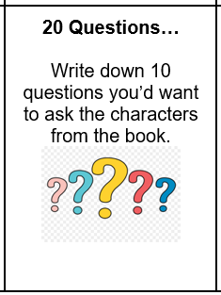
Reading

Maths and arithmetic
Do the red or blue tasks according to which you usually started with.

Science
Look at the human skeleton labelling sheet. Write the names of the bones in the correct places.

