Literacy

Can you read these alien words?

Can you write your own? Use the sound mat to help you.

peef lef

tayb tarp

deeb

Maths

Look at the dienes. Can you find how many tens and ones?

Remember:

Monday

Year 1 Starlings home learning Week 9.





= 1 10 =

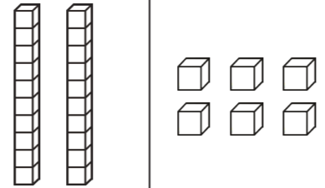

RWInc

Can you hold the sentence?

Read, say, hold, write, check!

The green leaves are on the tree.

Word time:

Can you write a full sentence using the word: full

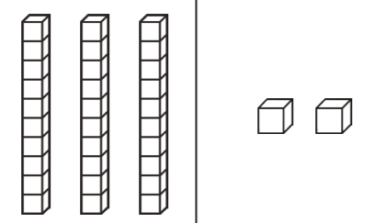

Maths

Oh no! Miss Christopher has not completed her number line. Can you write or say the missing numbers?

Tuesday

Year 1 Starlings home learning Week 9.

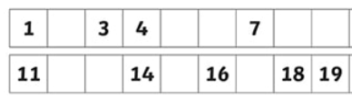

RWInc

**Reading:** Can you read these words? Remember special friends, fred talk, read the word.

**igh**

**high flight**

**might fright**

**light right**

Literacy

Choose 3 or words and write them in full sentences.

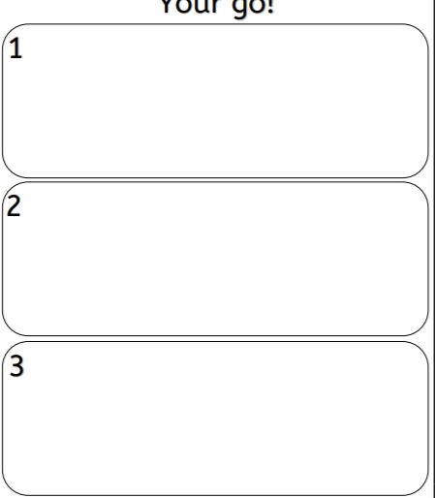

Science

Watch this amazing video from the Dominican Republic! Look at that beach! Use your senses and complete this sense walk sheet. Use your imagination

<https://www.youtube.com/watch?v=NLs3LqVgpT4>

Wednesday

Year 1 Starlings home learning Week 9.

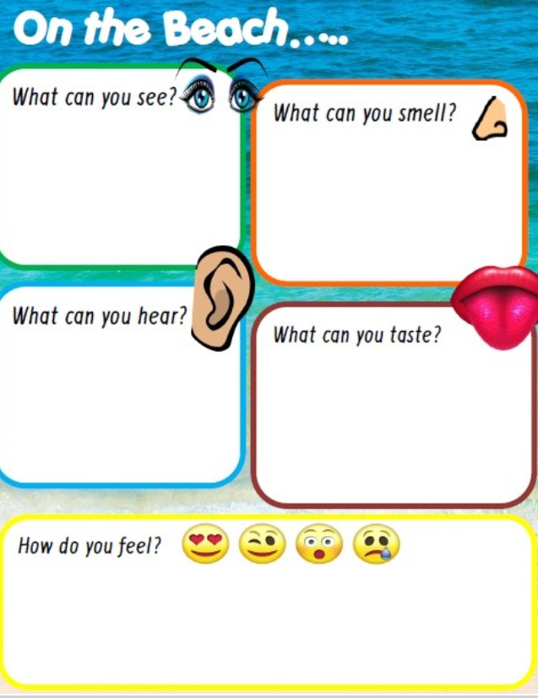

Maths

Can you count to 50 in 1’s while jumping on one leg?

Can you count to 40 in 2’s while star jumping?

Can you whisper and count to 100 in 10’s?

RWInc

Can you hold the sentence?

Read, say, hold, write, check!

I have a yellow balloon.

Word time:

Can you write a full sentence using the word: were

Literacy

Look around the house. Can you find objects that begin with these letters? If you cannot find them can you think of your own.

Maths

Can you find the total? Draw you dots to help!

10 + 3 =

13 - 6 =

9 + 9 =

12 - 1 =

Thursday

Year 1 Starlings home learning Week 9.

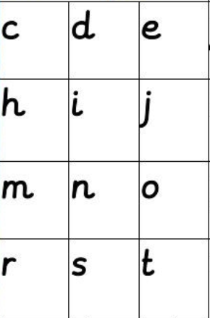

RWInc

**Reading:** with your grown-up or on your own reading out loud, can you read the story?

Remember if it is tricky: special friends, fred talk, read the word.

Meg is sitting in a chair reading a book. The book is called ‘Spot the dog’. Meg loves this book. She can read the book to her Mum, dad, and friend Tom. What is your favourite book?

Literacy

Can you practise writing the letters?

g s n m

Write three sentences to describe the weather today.

What does it look like? (sunny, rainy, cloudy)

What does it feel like? (breezy, warm, cold)

Maths

Can you find the total? Draw your dots to help!

10 + 2 =

12 - 0 =

20 – 7 =

4 + 4 =

Friday

Year 1 Starlings home learning Week 9.

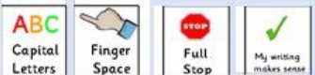

PE Challenge

Time for an under the sea yoga with cosmic kids. Follow the link below.

[https://www.youtube.com/w atch?v=YR1OxBk8BF4](https://www.youtube.com/watch?v=YR1OxBk8BF4)

RWInc

Phonics play:

Login to phonics play using the code

Username: march20

Password: home

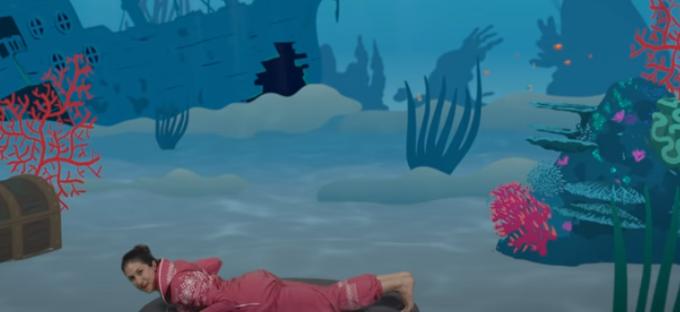

**Resources:**

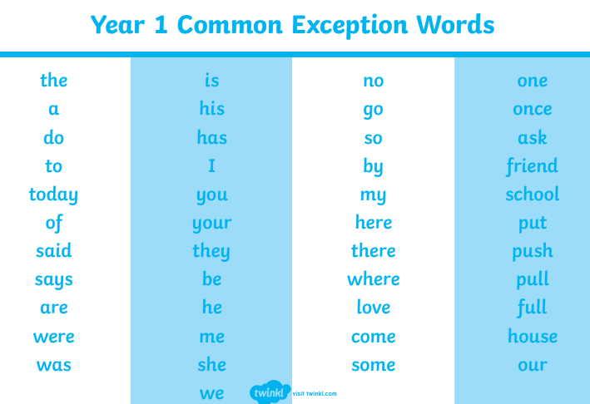Here are the Year 1 common exception words and Read, Write, Inc sound mat we use in class.

