Hello Y5 Harriers and Kestrels!
We hope you are staying safe and washing your hands regularly. We cannot wait to be back at school with you all in this glorious weather!
Here’s some home learning, to complete this week, to keep yourselves busy! Please make sure you put lots of effort into the work, in order to keep up your fantastic progression!

Cleopatra and Cupid love to escape their rabbit run. They have been sneaking out and eating all of Mrs Needham’s (Miss Needham’s mum) plants!

Maths:
Log into Times Tables Rockstars at www.ttrockstars.com/
Your challenges await!
If you need your username and password, ask an adult to email us.

Here’s a table for you to complete each week. I would like to challenge yourself to complete a times table grid each day and submit your score. Let’s keep track of your progress each week. Your challenge is to beat your last score. Don’t forget, set a 3 minute timer. Once the timer finishes, put your pencil down immediately. Then, mark your answers and add your score out of 100 to the table below.

 | Monday | Tuesday | Wednesday | Thursday | Friday
Score
/100

Monday:

× | 2 | 5 | 3 | 4 | 8 | 6 | 7 | 9 | 11 | 12
10
2
5
3
4
8
6
7
9
11
Tuesday:
× | 2 | 5 | 3 | 4 | 8 | 6 | 7 | 9 | 11 | 12
10
2
5
3
4
8
6
7
9
11

Wednesday
× | 2 | 5 | 3 | 4 | 8 | 6 | 7 | 9 | 11 | 12
10
2
5
3
4
8
6
7
9
11
Thursday:
× | 2 | 5 | 3 | 4 | 8 | 6 | 7 | 9 | 11 | 12
10
2
5
3
4
8
6
7
9
11

Friday:
× | 2 | 5 | 3 | 4 | 8 | 6 | 7 | 9 | 11 | 12
10
2
5
3
4
8
6
7
9
11

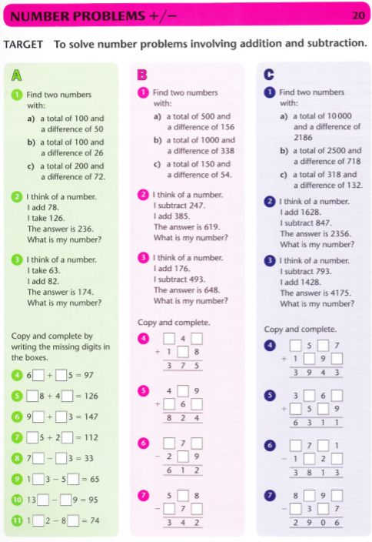
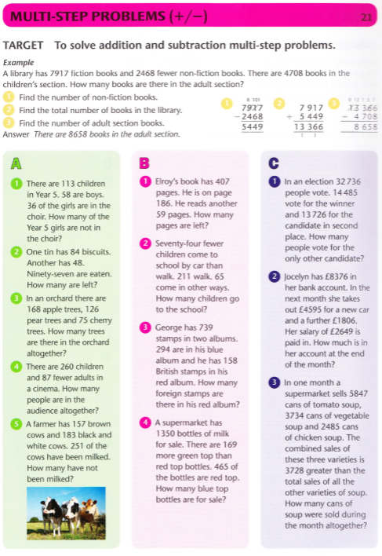

Extra maths:

https://www.bbc.co.uk/bitesize/topics/zd2f7nb/articles/zn2y7nb
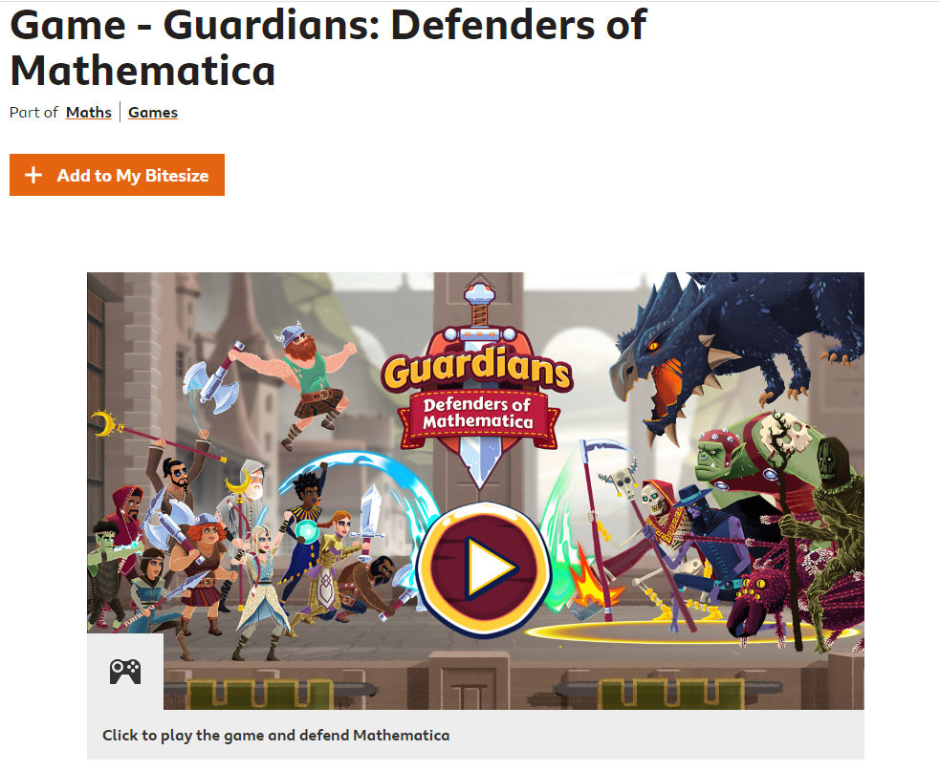

Reading
Mr Jones’ Group
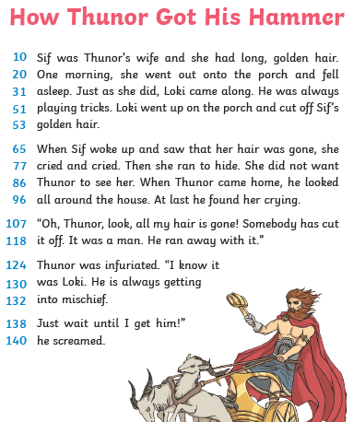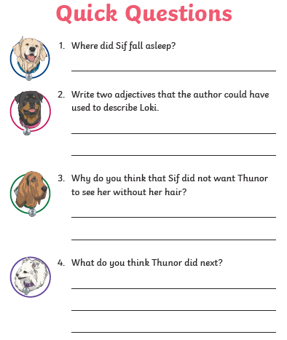

Miss Needham’s group:
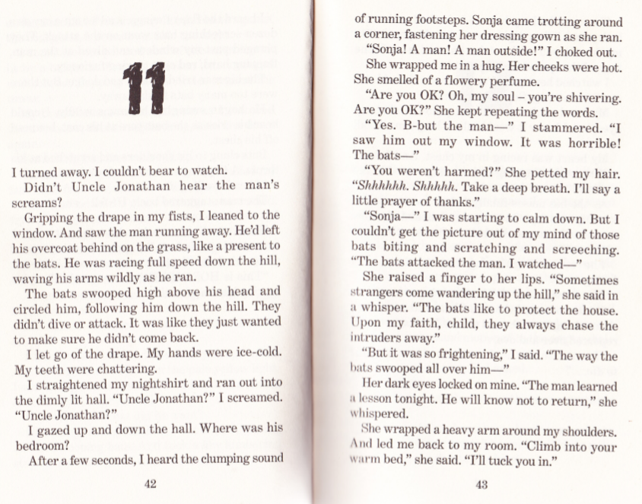
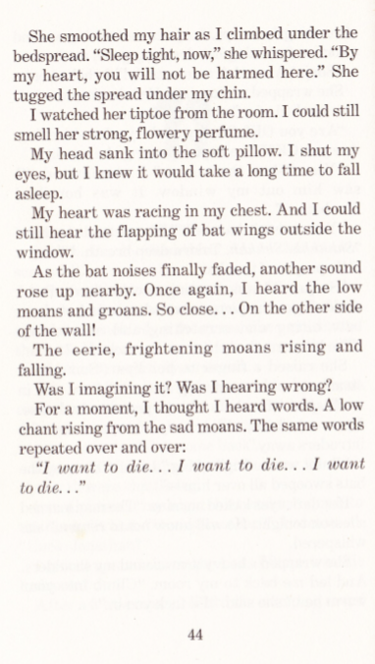

Your challenge is to write the next chapter of the story. It’s totally up to you what happens next!
Don’t forget your similes, metaphors, alliteration, personification and more!

Mrs James’ group:
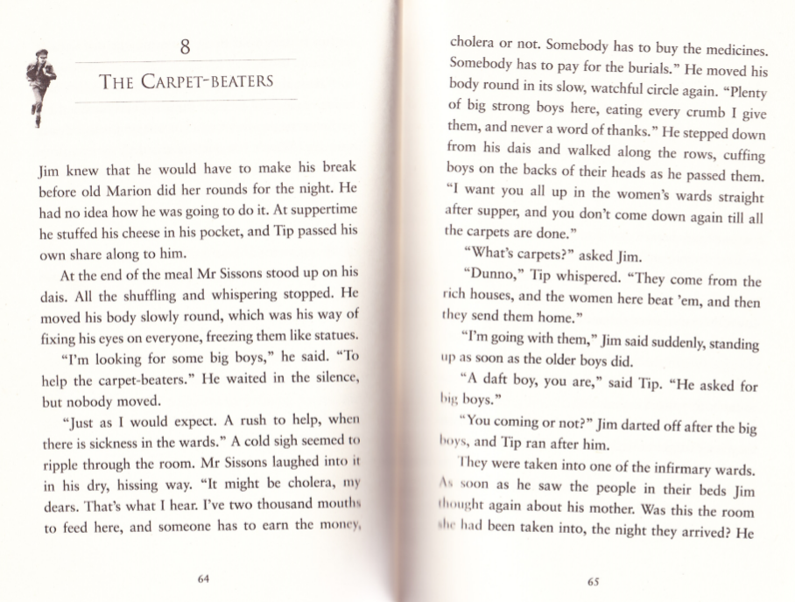
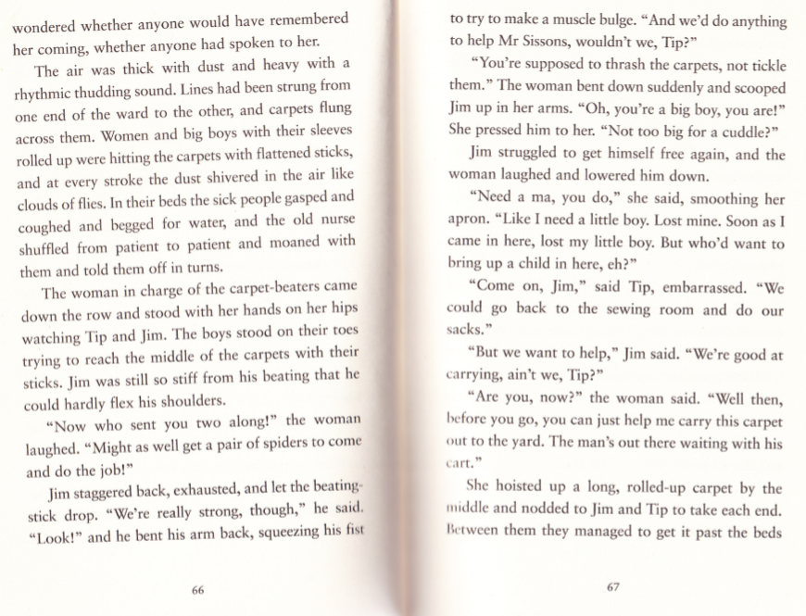
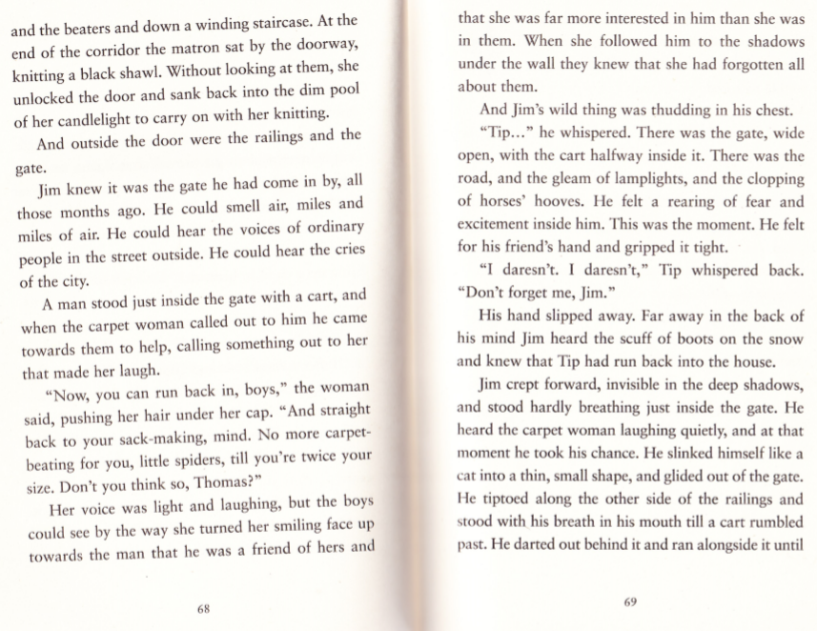
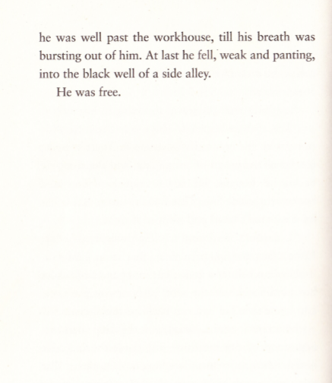

Your challenge is to write the next chapter of the story. It’s totally up to you what happens next!
Don’t forget your similes, metaphors, alliteration, personification and more!

Grammar – Mr Jones’ group:
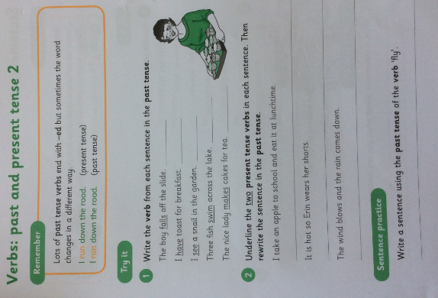

Miss Needham’s and Mrs James’ group:
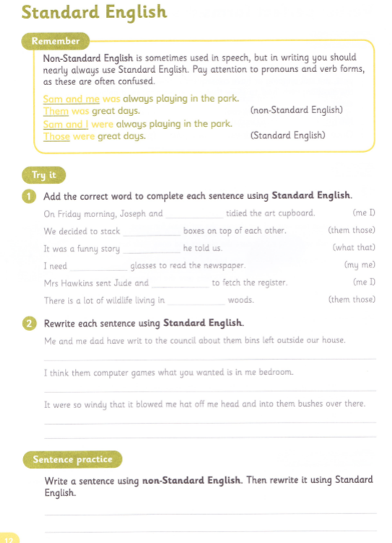
English
This week we will be looking at a non-fiction text- Instruction Manuals.
These can be used for all kinds of different everyday help from putting together a piece of furniture to mending a car. Often we will turn to YouTube to help us with a ‘how to’ video but it is always good to have a back-up plan.

Details about instruction manuals can be found here which will act as a guide to help you.

You have a choice of three things to write yours on. You can pick one or, if you are feeling inspired, have a go at them all. You could even take a picture and send it to your really great teacher.

- Baking a cake
- Building a Lego house
- How to play your favourite board game

To expand your knowledge further use the traffic lights below and you’ll get an even deeper knowledge.

You need to include Capital Letters, full stops and use the words appreciate and attached in your writing.

Use time conjunctions such as after, before, during, next, suddenly, then and when to help everything make sense to the reader.

Use plural and possessive s in your writing. These is a short video to remind you here

Top Tip
Use a piece of scrap paper to plan out your ideas and then write it up when you have it all pieced together.

Spellings
Here is a list of some spellings for you this week. Can you use these to help you learn them? Get your grown up to test you on Friday when you’ve had a week to learn them.
available average awkward bargain bruise category cemetery committee communicate community

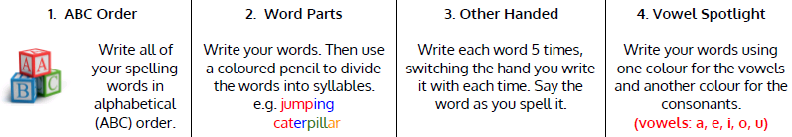

Art
With lock down museums have put together virtual tours which are great if you want to have a look around some amazing art. Here is one collection of art from the British Museum.
You just need to pick one that you’s like to have a try at drawing and off you go.

Spanish
Here is some Spanish which is all about the classroom. The details are all here and if you feel like moving on to something else on this website please feel free to challenge your learning.

Go to www.languageangels.com
Click Login
Click Home School
Use these to log in
Username: LowerM194 Password: lahome
Click the Spanish flag and
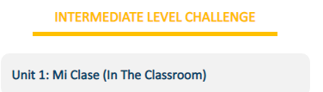
Away you go.

Science
Throughout the past few months the orbit of Venus has meant that it is visible from Earth without a telescope. With some good cloudless nights you have been able to see Venus just to the side of the Moon. This short video shows this for you – The orbit of Venus

This week I would like you to draw the orbits of the planets around the Sun. I have put a link to this short video to help you but have put this image too which will help you.

Super Science
Write a fact about each planet as you draw them on to add more information to your diagram.

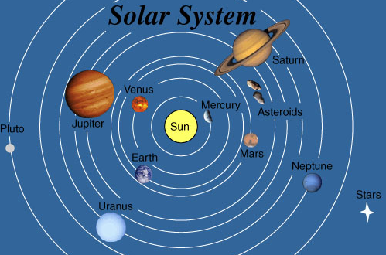
Note: Before anyone tells me I know Pluto is classified as a dwarf planet now but wanted to include it along with asteroids and stars. You have permission to add any other satellites etc.

Extra:
