Year 4 - Week Ten Home Learning

Dear Year 4 children and their adults,

Here is the tenth week of learning. Below is a checklist to help you keep track of what work you have done and what is left. You are welcome to do both the black and blue tasks regardless of what you normally do in class. This work can either be printed out and done on the sheet or on a separate piece of paper you already have.

- x5 Times Table – Sheet 1
- x5 Times Table – Sheet 2
- x9 Times Table – Sheet 1
- x9 Times Table – Sheet 2
- Story Settings Description 10
- Book review
- ‘Interrogative and Demonstrative’ worksheet
- ‘Arthur’s Article’ sheet
- Spellings (Black/Blue)
- Handwriting
- ‘Sun Safety’ reading comprehension
- Cornflour Slime science experiment
- Computing – “Words and Feelings”
As with all the previous weeks, in addition to the set work, here are some other tasks that the year 4 children are expected to do every single day (I’ve attached a timetable for you to tick these things off).

I would encourage adults to continue to email me with photos of work or to give special recognition to their hard-working child(ren)!

60+ minutes of Rockstar Maths (This is available on both iOS and android as a free app, the children should have their logins already, usually found in their reading record, if you do not have access to the login details, please email me)

60+ minutes reading a book of their choice (Either a book at home or a book online; the Sheffield Library allows you to make a free account on their app RBdigital and read lots of free books online, I cannot recommend this enough!)

60+ minutes of exercise (Joe Wickes has a fantastic workout livestream every morning on YouTube, but you can also design your own workout which I’m sure will be even better) – I want to hear about how many push-ups you can now do, our goal is to be able to do 10 more than you could first do.

Between 15-30 minutes of meditation (This can be done over two or three mini-sessions) (Think back to our amazing trip to the Hindu temple; find a comfortable sitting position and think about something that is important to you e.g. your adults, your sibling, your best-friend, a god, etc)

Tick every activity they do each day. If they don’t do one of the activities, it means they have to do it for double the length the next day!

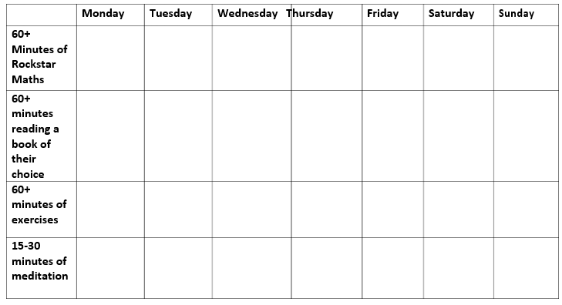
Give it a double tick if they really put in the hard work
Other links to useful resources:

https://www.twinkl.co.uk/ (You can sign up for a free month)

https://www.forgessp.co.uk/home-learning-resources (A HUGE collection of home learning resources!)

https://apps.apple.com/gb/app/times-tables-rock-stars/id973811326 (Rockstar Maths iOS)

https://play.google.com/store/apps/details?id=com.ttrockstars.app&hl=en_GB (Rockstar Maths android)

https://www.sheffield.gov.uk/home/libraries-archives/the-elibrary (Free Sheffield elibrary resource)

I wish you all the absolute best and don’t hesitate to email me if you have any questions or concerns,

Remember Year 4s, NO EXCUSES!

Mr Merry
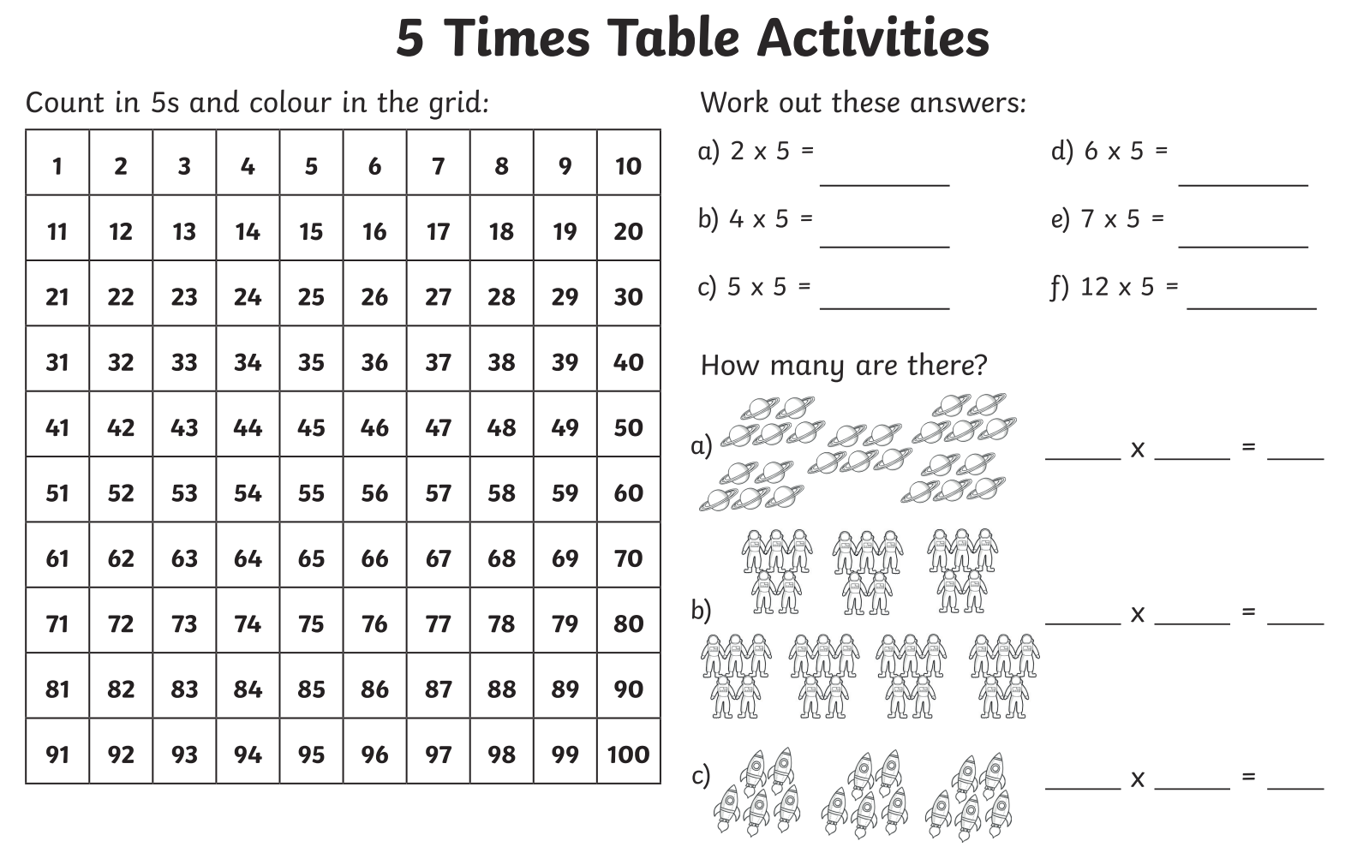
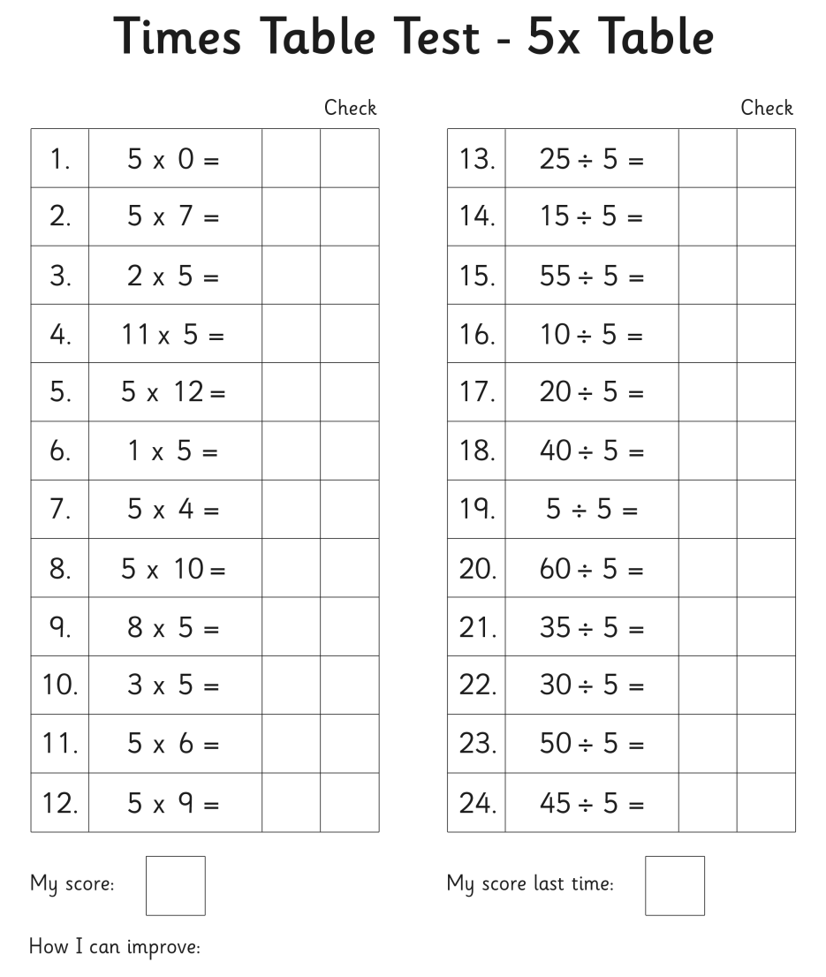
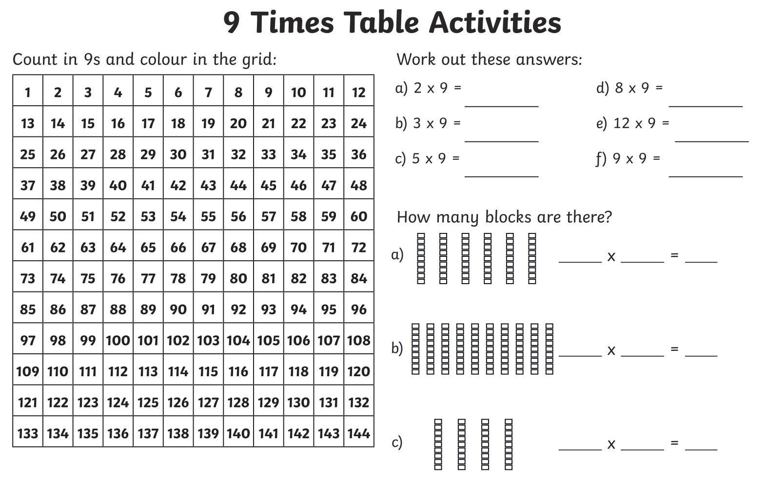
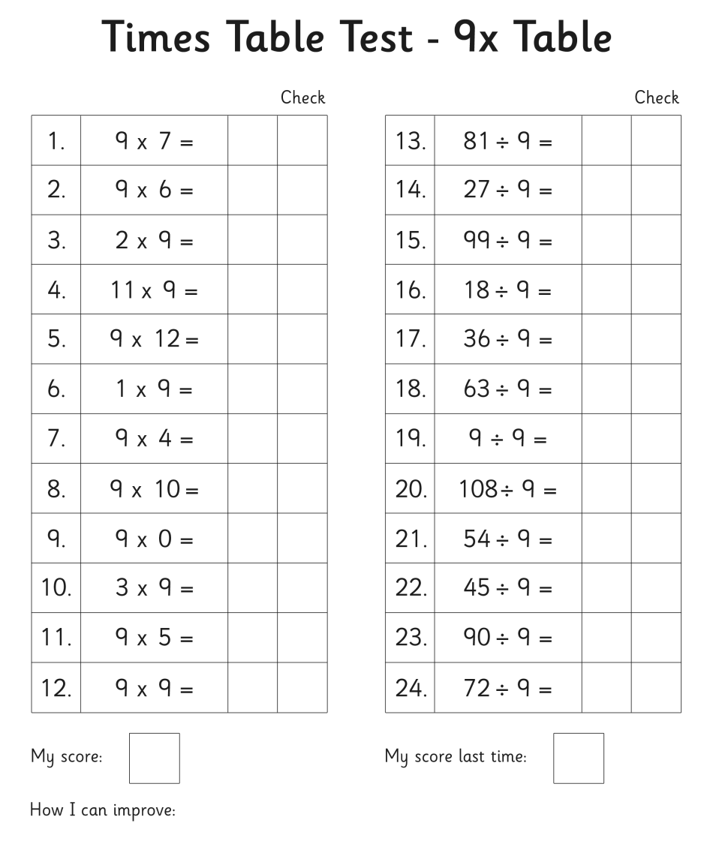
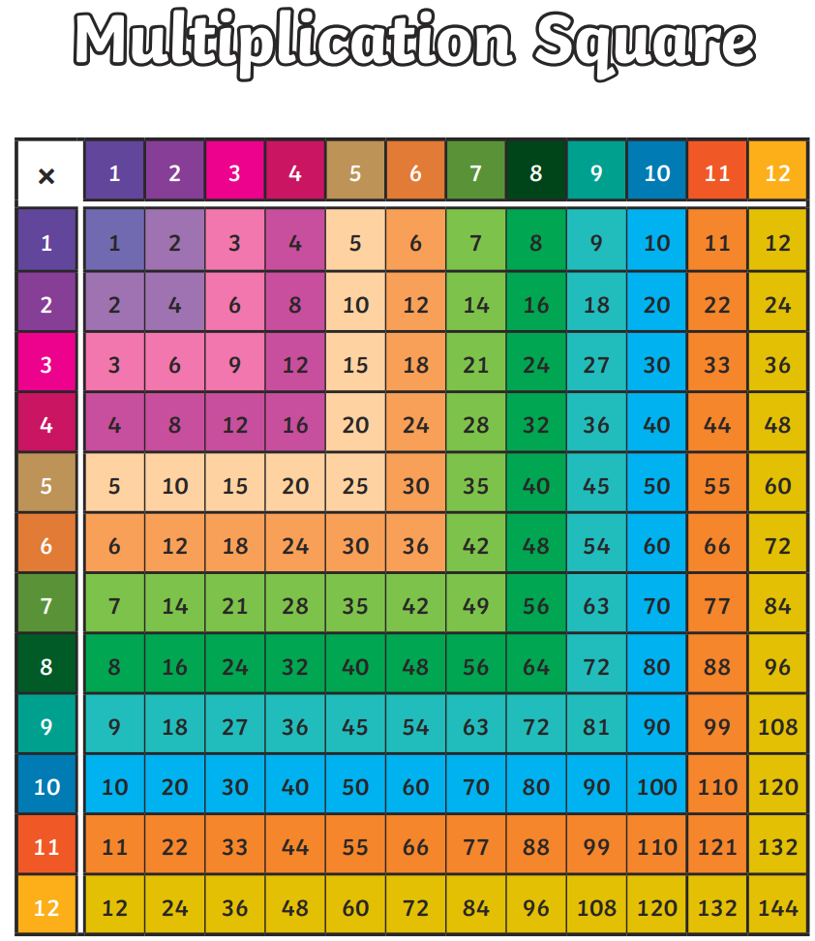
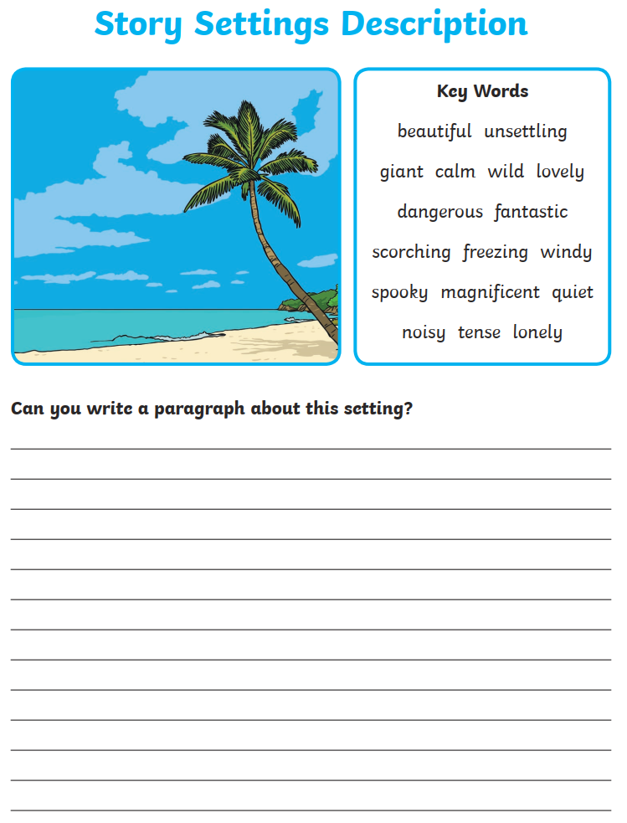

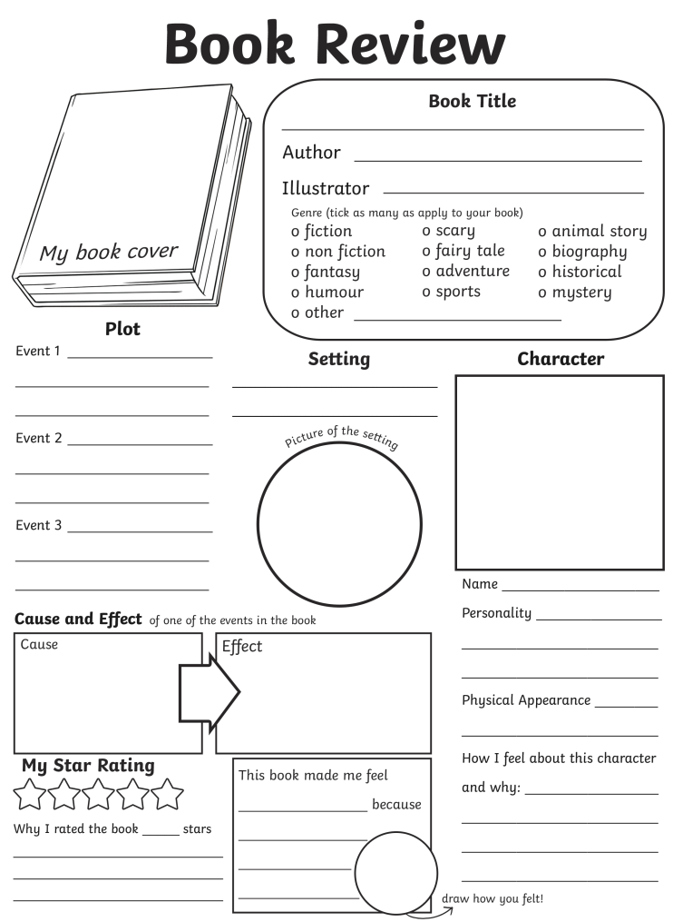

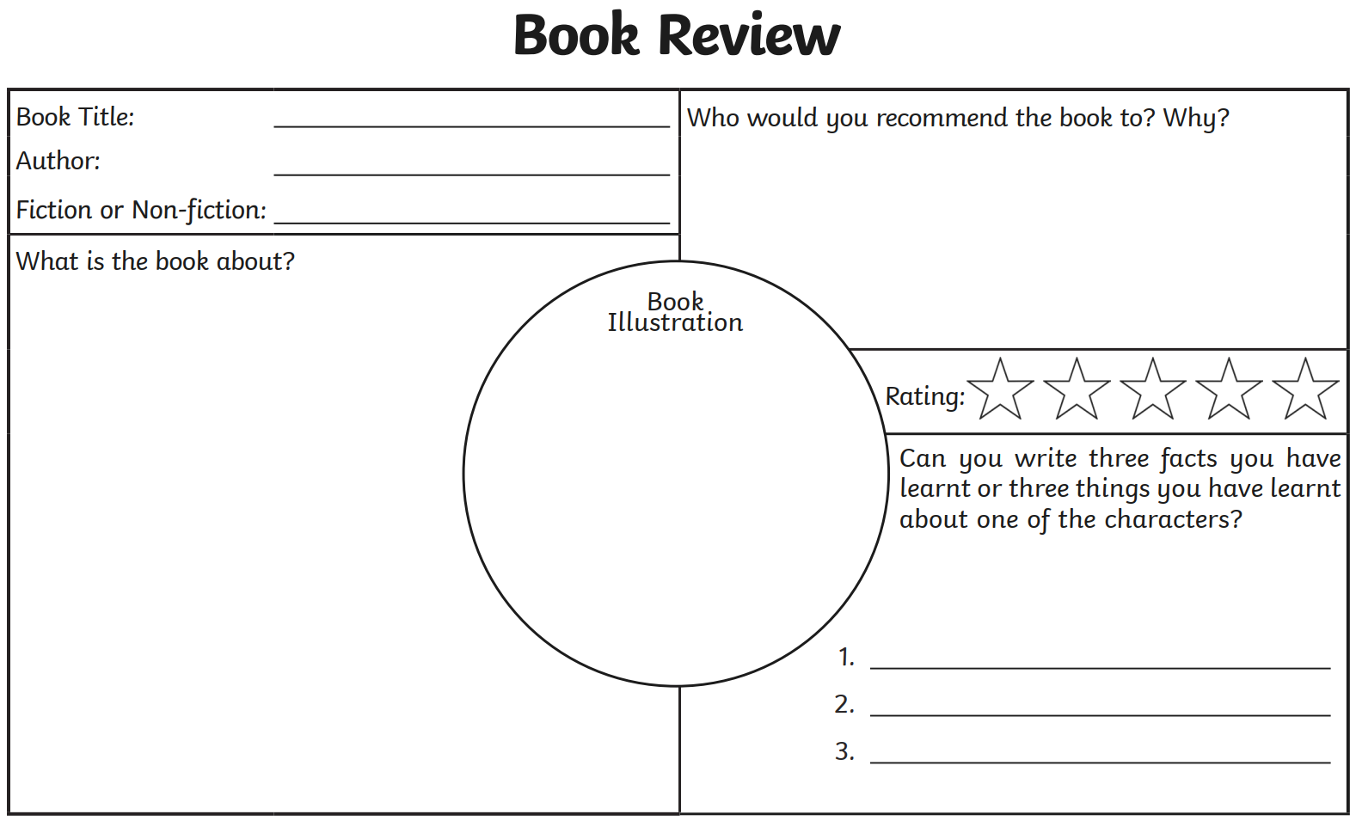
A determiner is a word that is used to modify the noun (e.g. his jumper, her pencil, that car). We have lots of different types of determiners which we will go through.

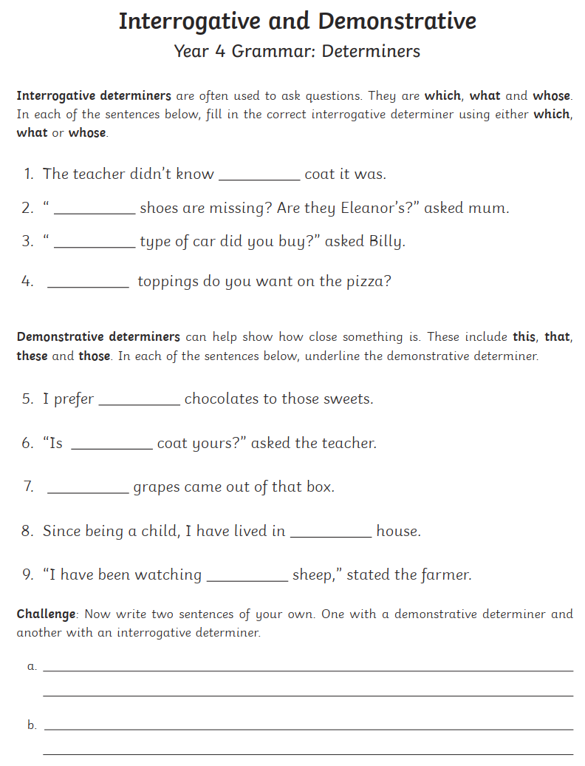
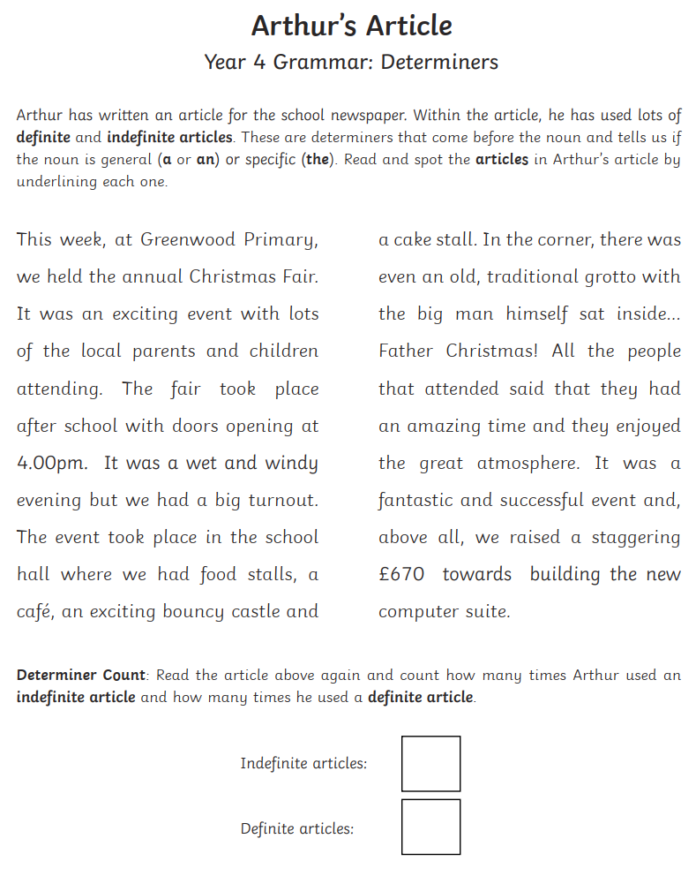

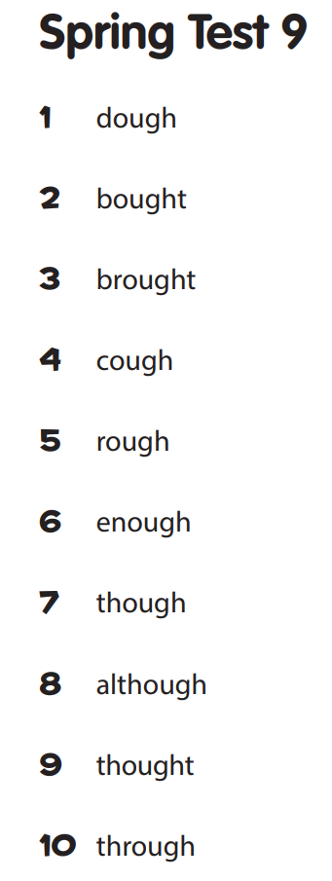
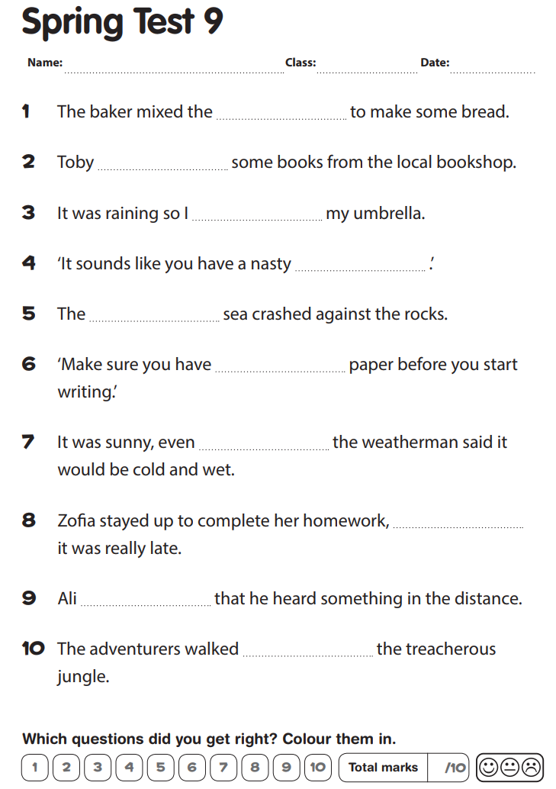

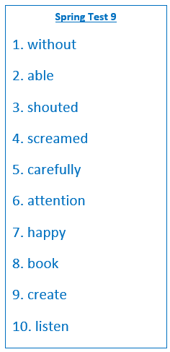

1. You shouldn’t go outside in the cold ______________ a warm coat.

2. “Are you ____________ to spell of these words?” the teacher asked.

3. “NO!” Bobby _______________.

4. “YES!” Sandra ________________.

5. You must measure your ingredients ____________ if you want to bake a cake correctly.

6. “Please pay ______________” Miss Crab said.

7. Putting in the hard work always makes Mr Merry ______________________.

8. “What is your favourite _______________?” Sophie wondered.

9. “We can all _____________ something beautiful!” Mrs Park said.

10. To pay attention to what we hear, we must _______________.
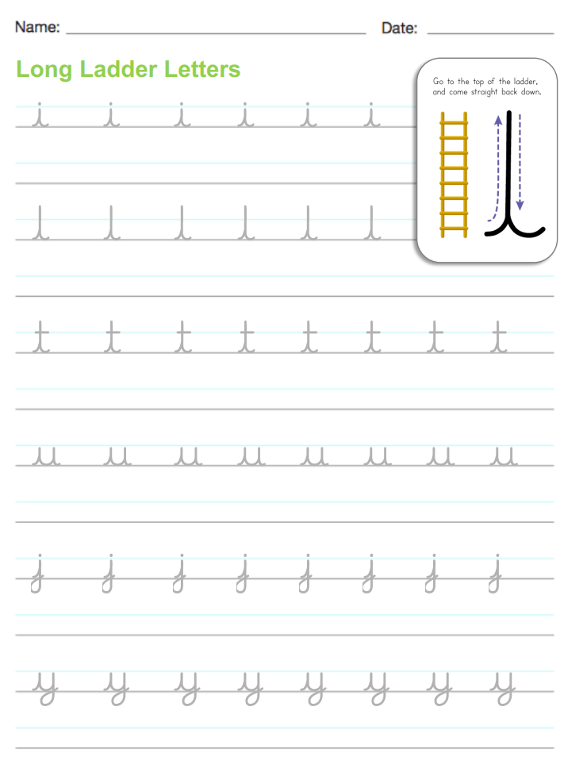

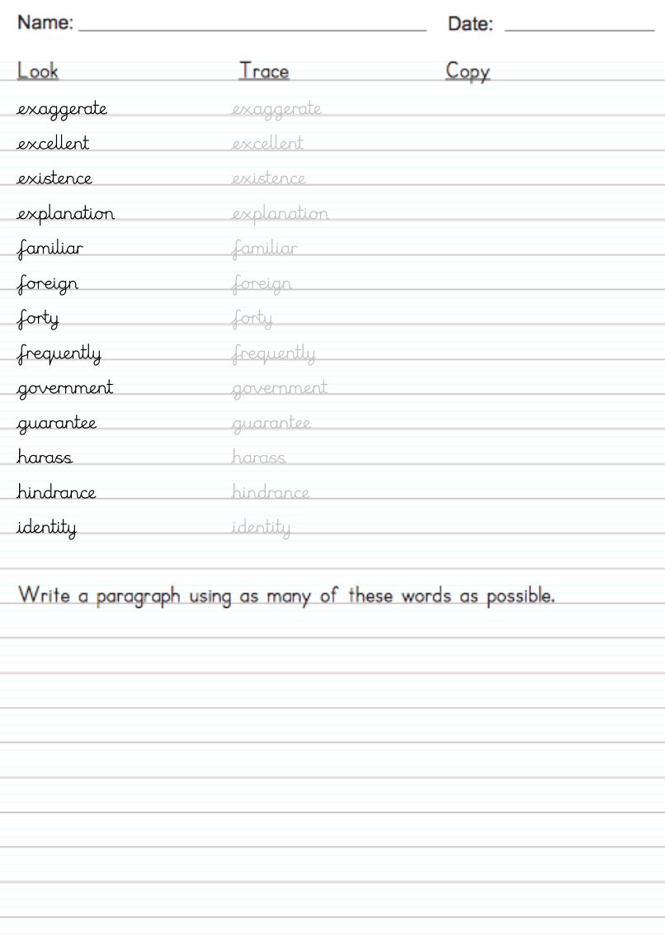

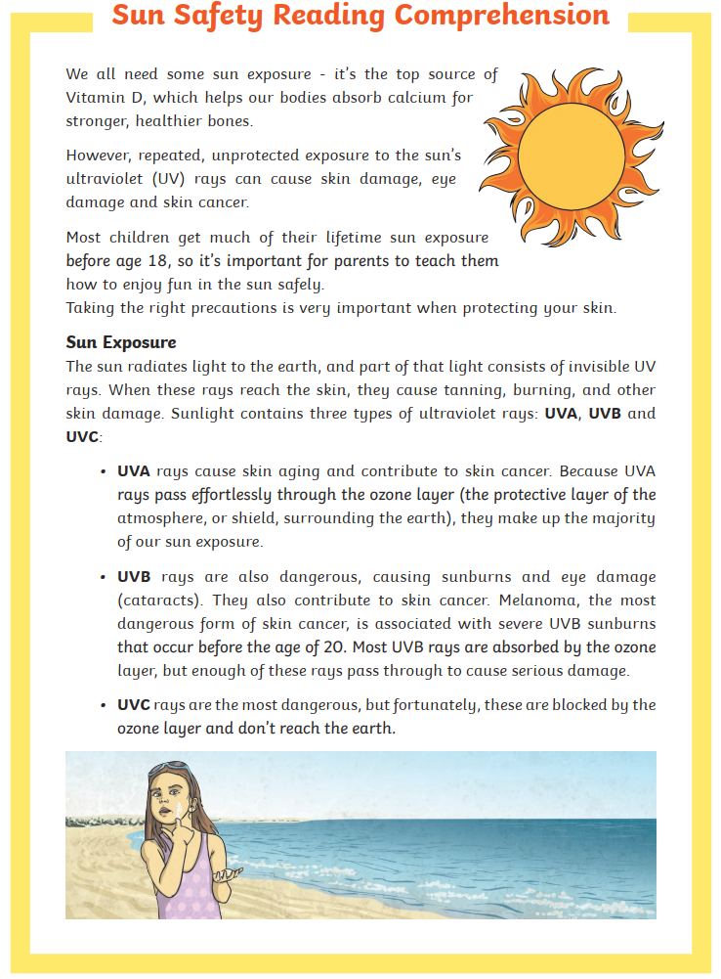

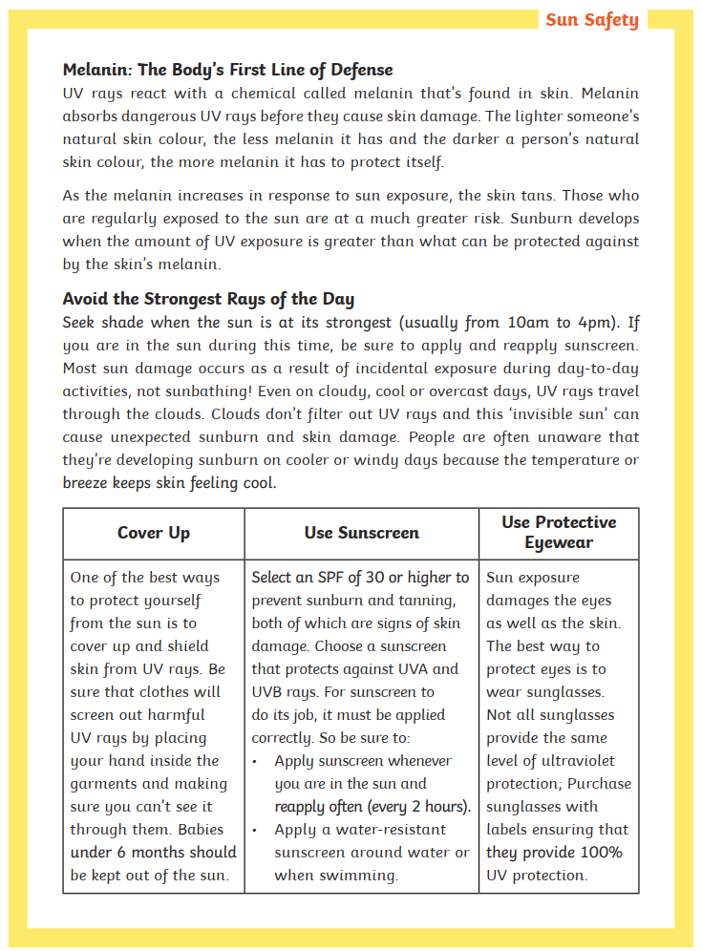

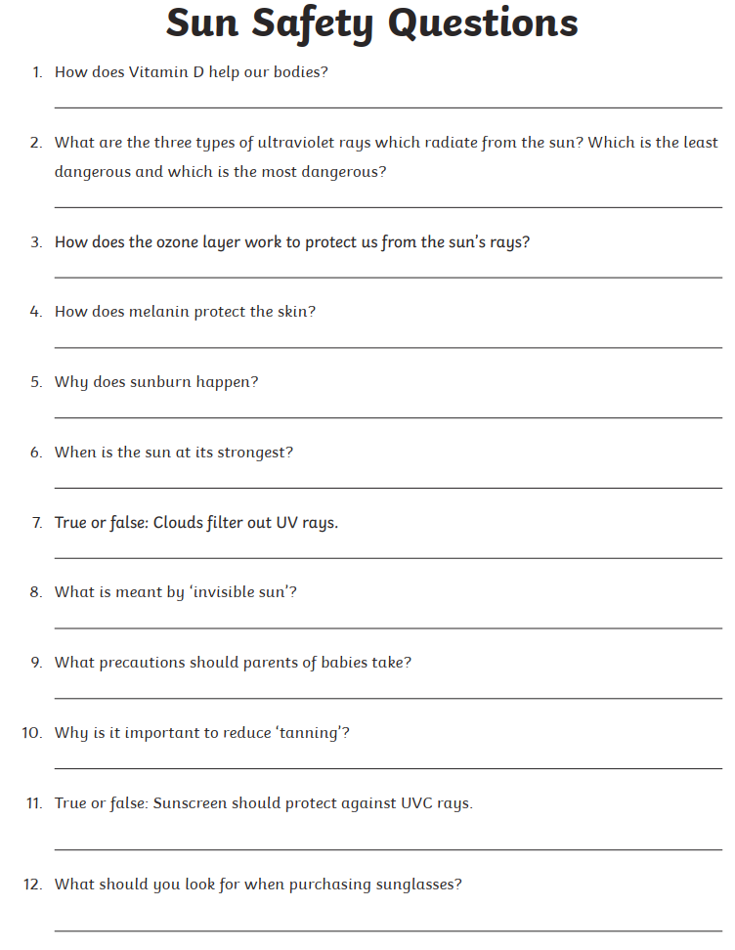

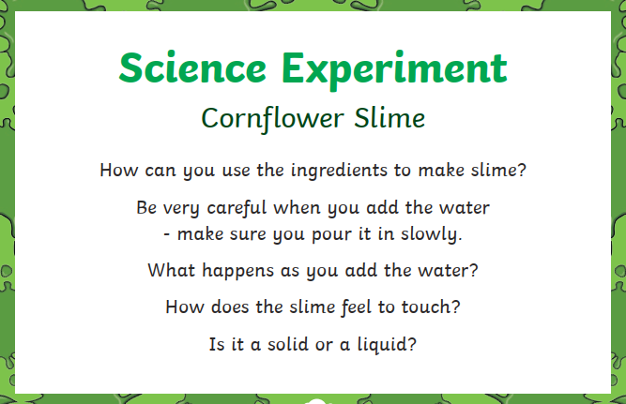
Remember to email me photos of your experiments!

Click here to email me!

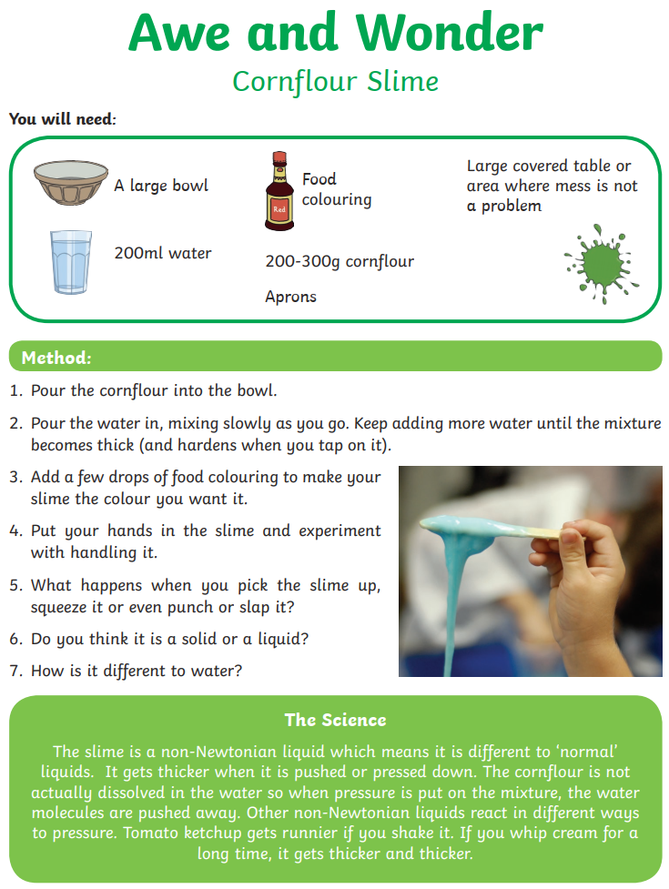
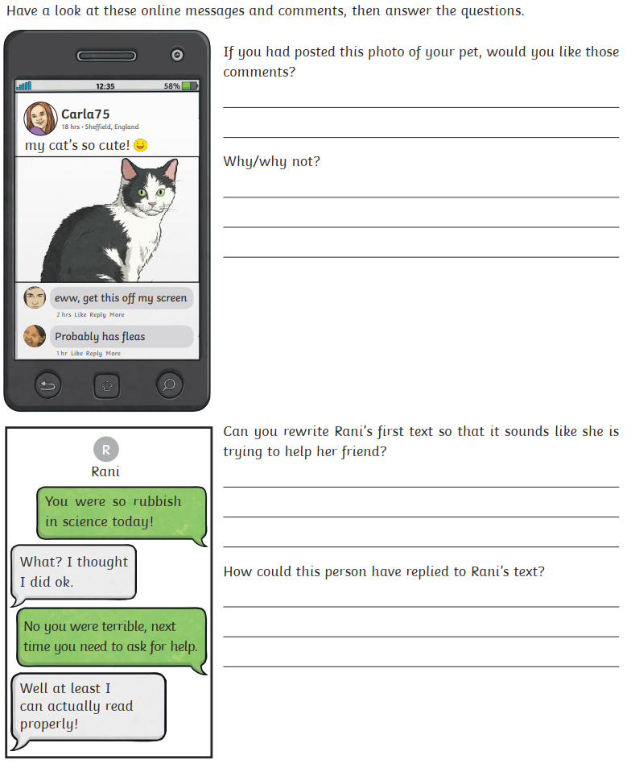
Words and Feelings

