Maths – week 8
If you normally do blue task:

- Find double of:

4

6

2

10

- Write your number bonds to 20.

- 2 x 3 =
2 x 1 =
2 x 0 =
2 x 10 =
9 x 2 =
11 x 2 =

- 10 x 10 =
10 x 0 =
10 x 1 =
9 x 10 =
10 x 8 =
4 x 10 =

25 ÷ 5 =
10 ÷ 5 =
5 ÷ 5 =
15 ÷ 5 =
6.
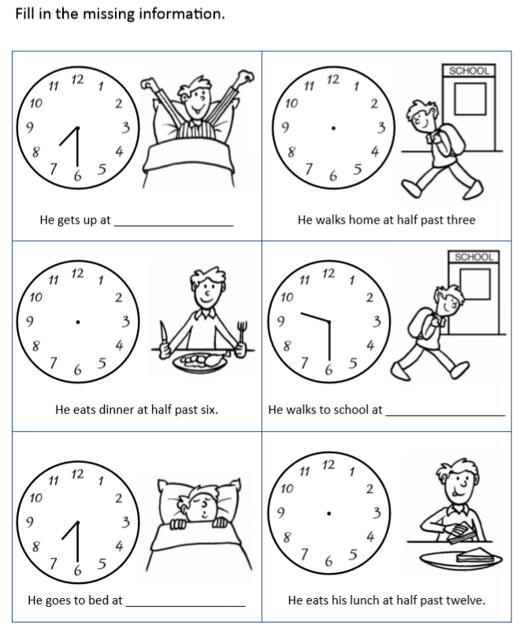
7.
How many apples are there in 3 groups of 2? _____

How many children are there in 4 groups of 3? _____

8.
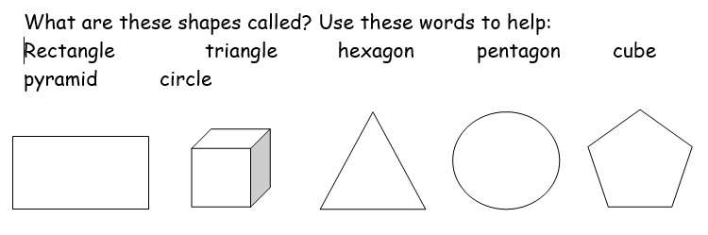

9.
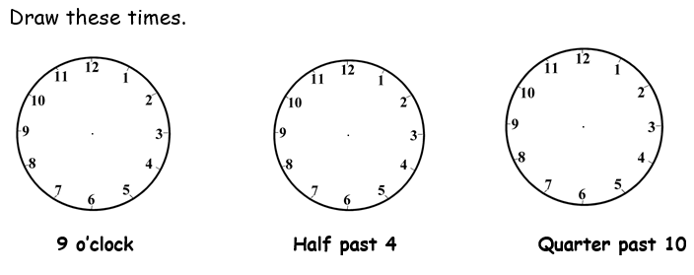

10.
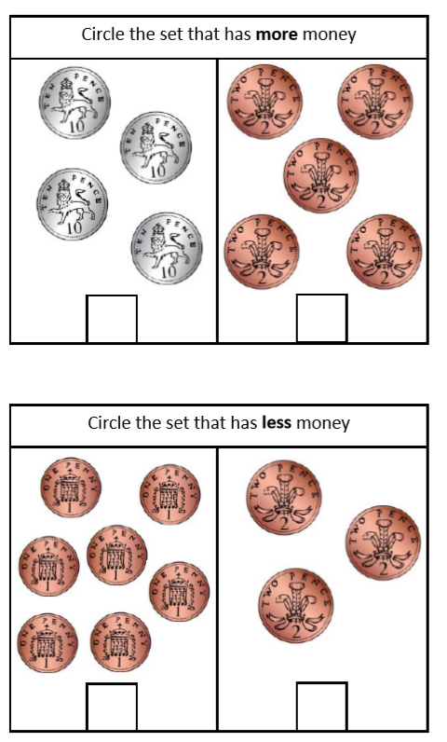

If you normally do red task:

Q1.
423 + 352 =

879 – 252 =

781 – 352 =

Q2.
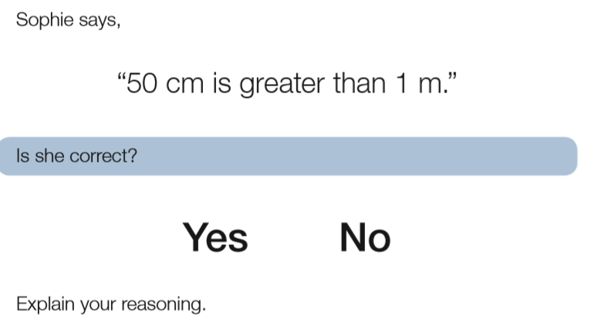

Q3.
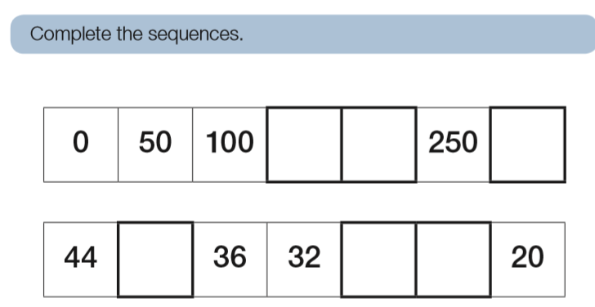
Q4.
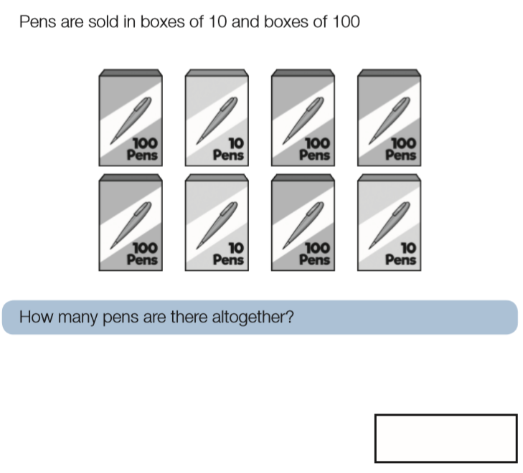

Q5.

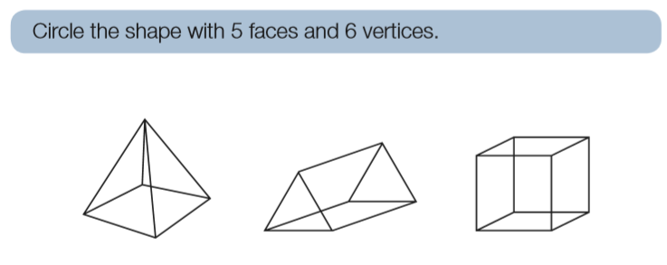

Q6.

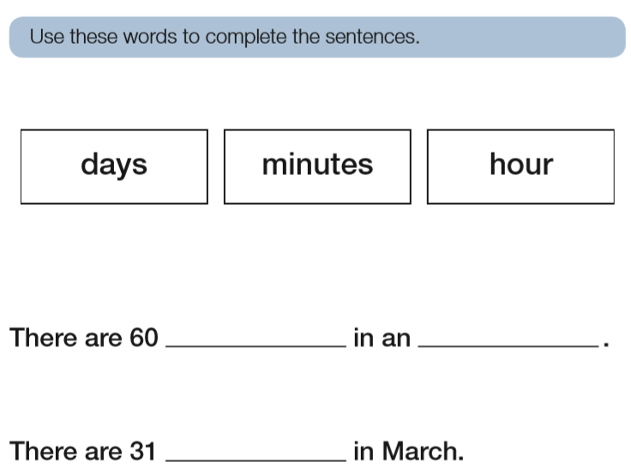

Q7.

Q8.
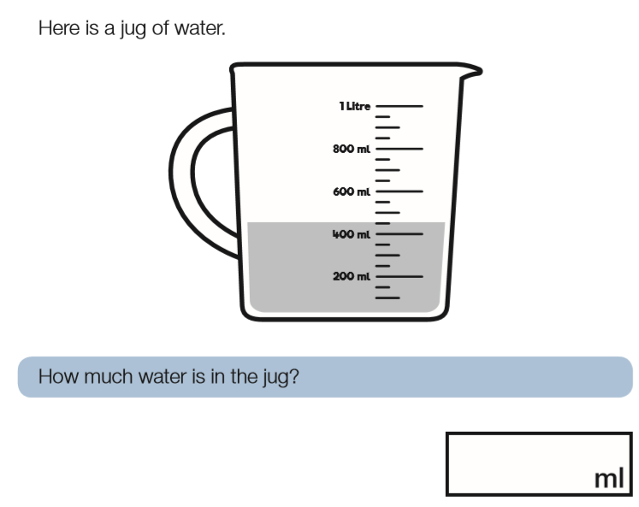

Q9.

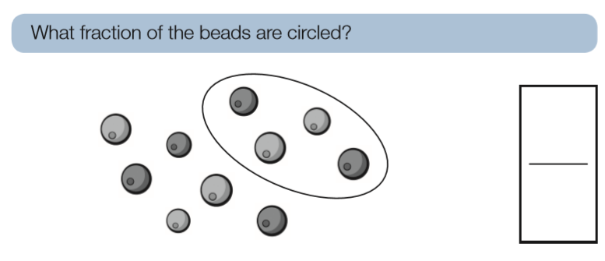

Q10.

