Maths – week 10
If you normally do blue task:

- Find double of:

4

1

6

10

- Write your number bonds to 20.

- 5 x 11 =
5 x 9 =
5 x 5 =
5 x 6 =
5 x 2 =
0 x 5 =

- 2 x 0 =
10 x 2 =
2 x 5 =
6 x 2 =
2 x 7 =
4 x 2 =

12 ÷ 2 =
70 ÷ 10 =
8 ÷ 2 =
20 ÷ 5 =

6.
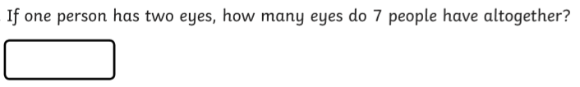
7.
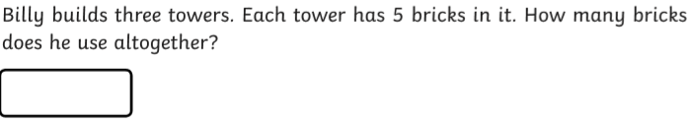
8.
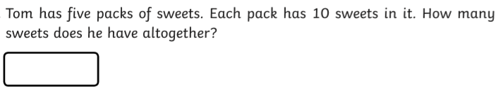

9.
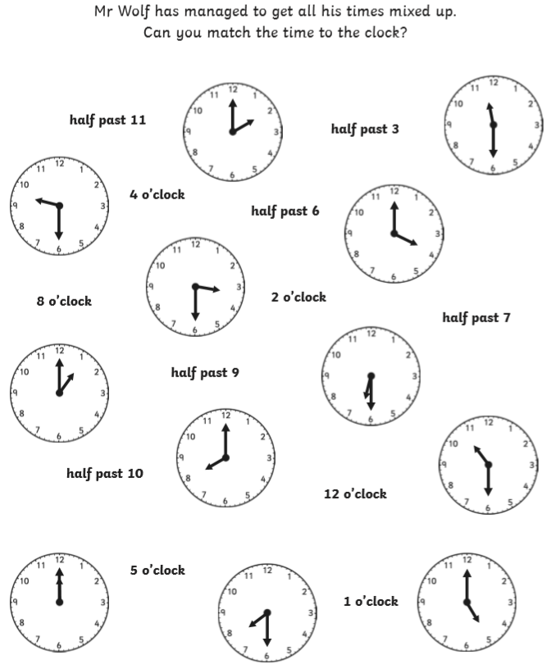

10.
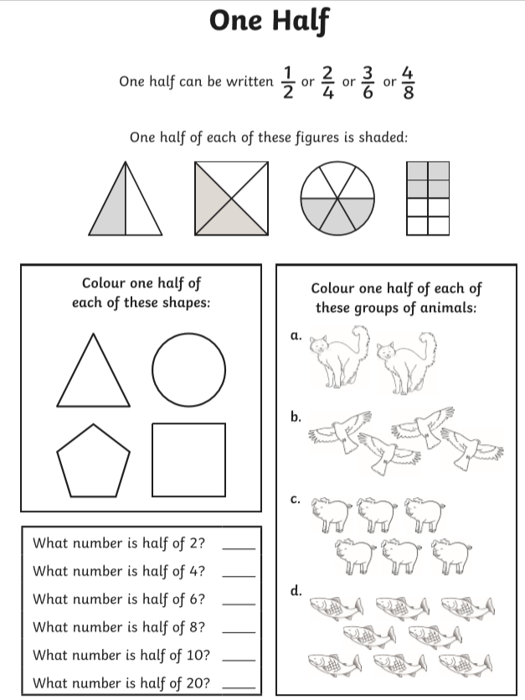

If you normally do red task:

Q1.
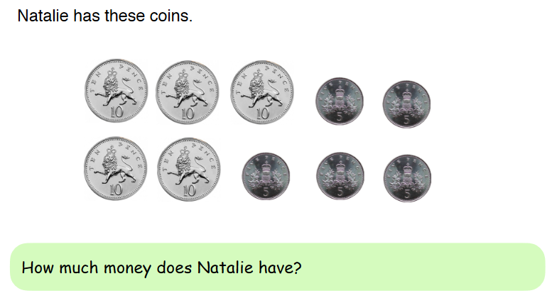
Q2.
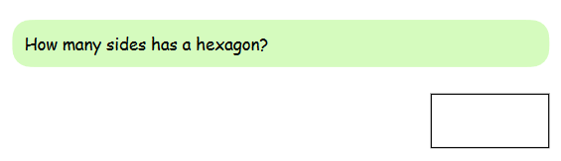

Q3.

Q4.
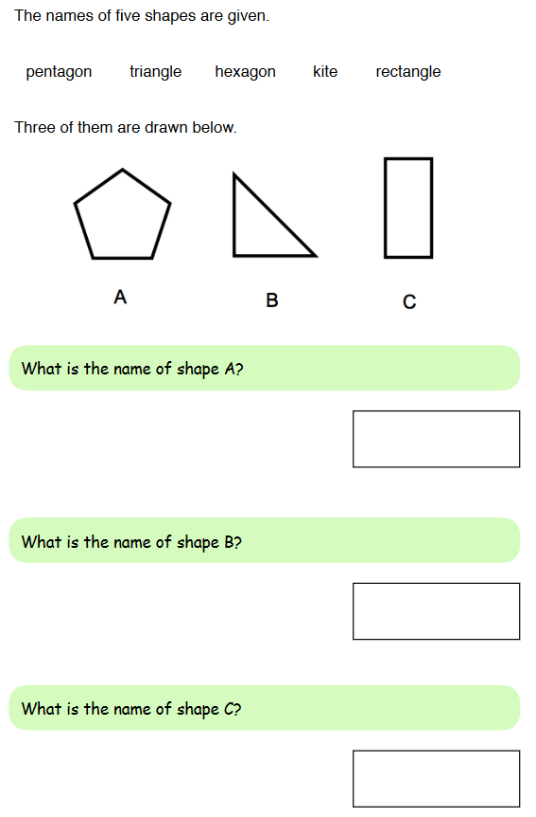

Q5.

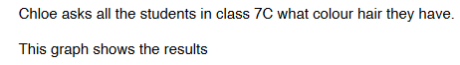
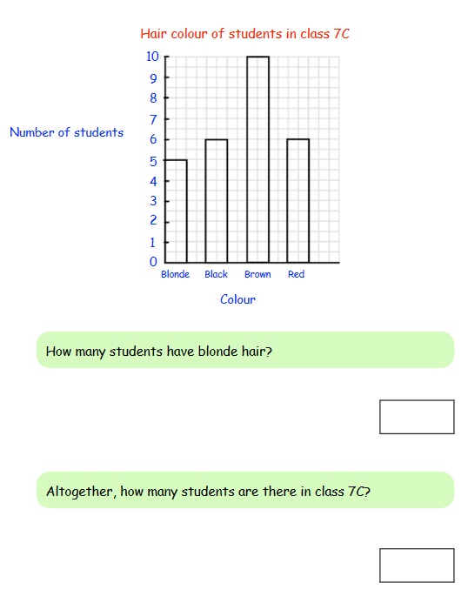

Q6.

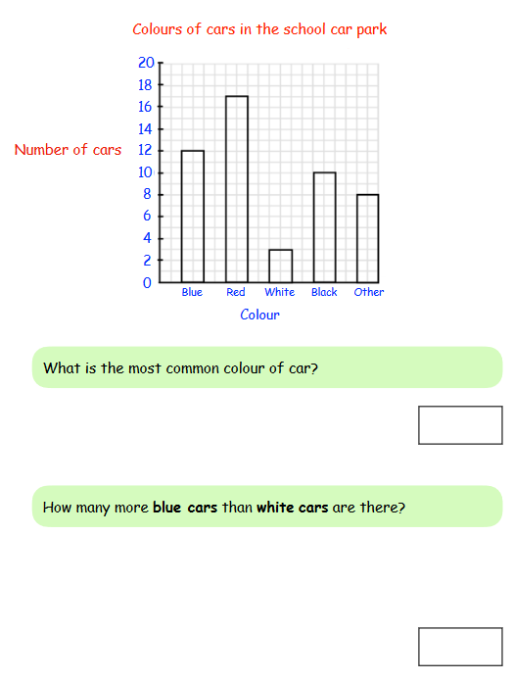

Q7.

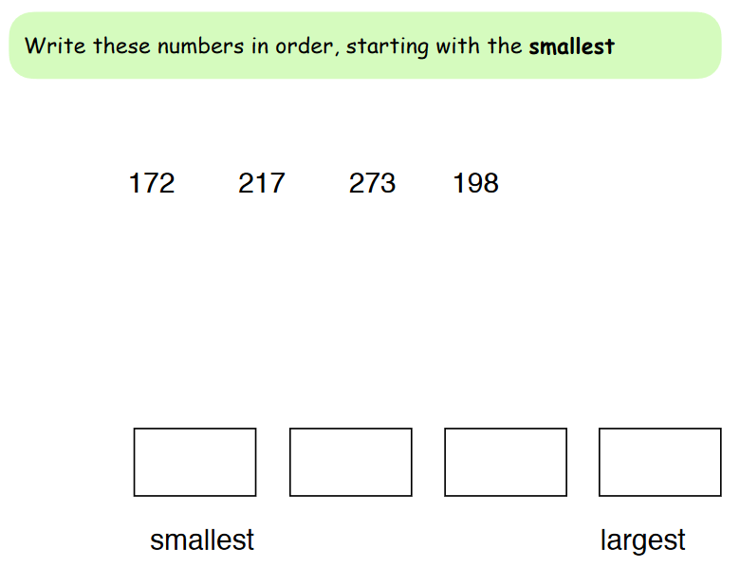

Q8.
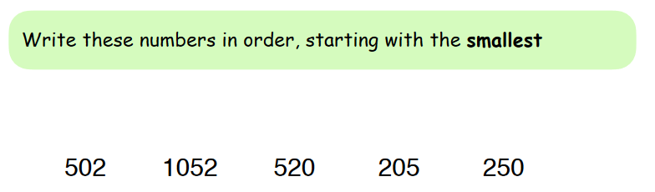

Q9.

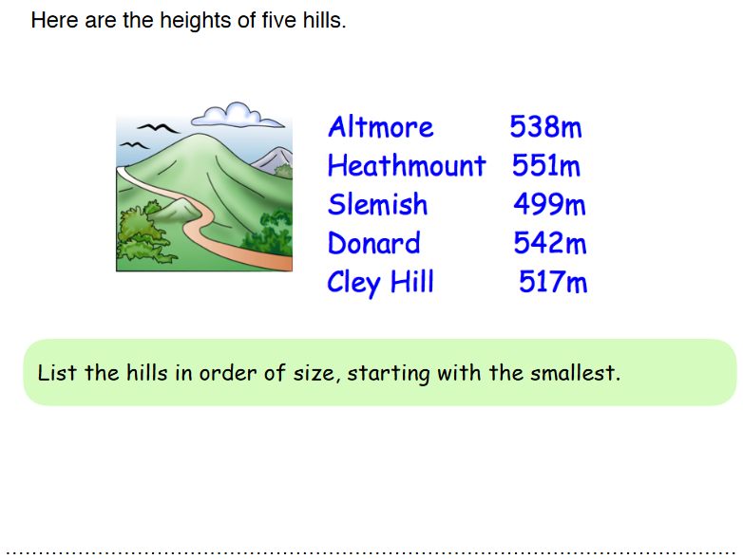

Q10.

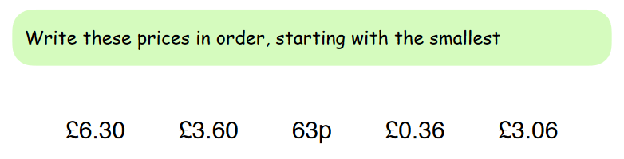

Q11.
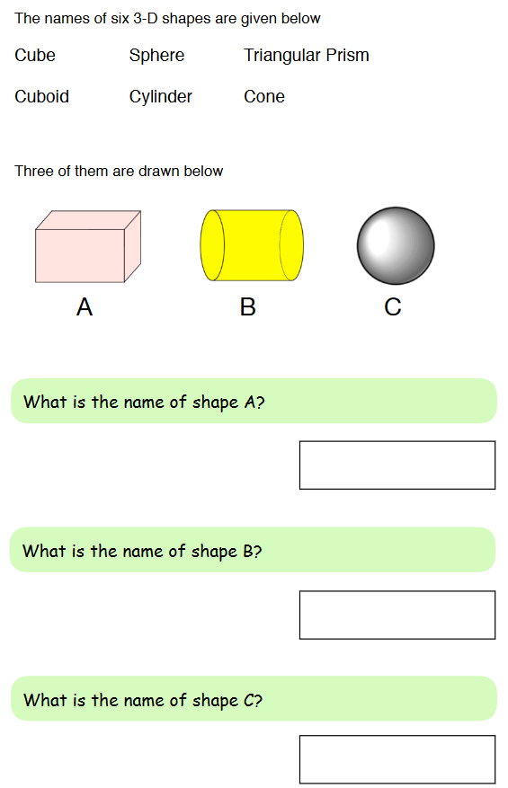

Q12.

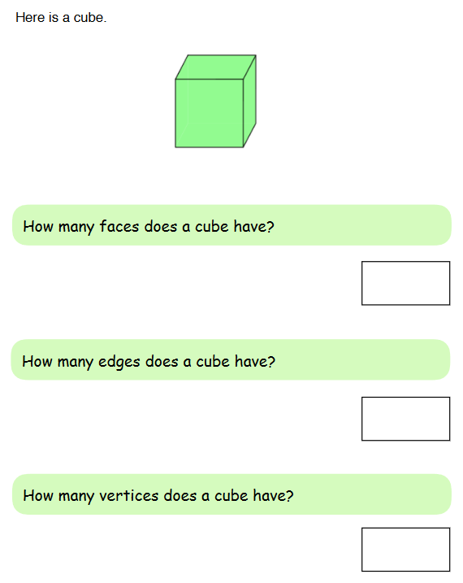

Q13.
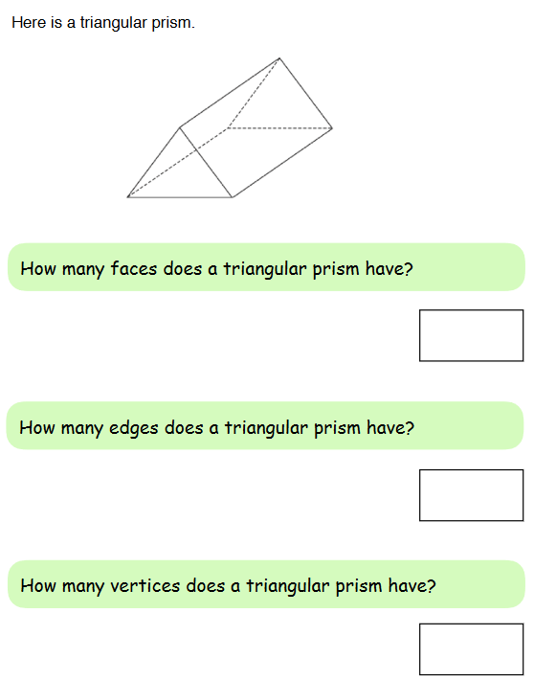

Q14.
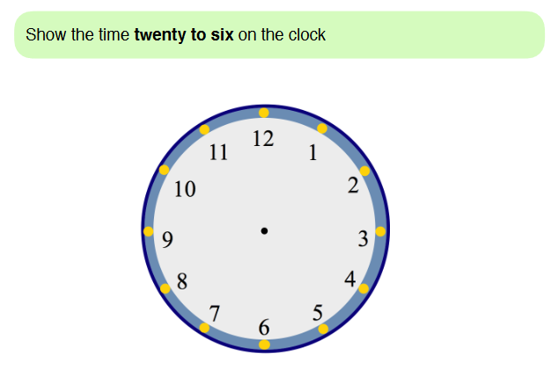

Q15.
