Hello Y5 Harriers and Kestrels!
It was lovely to catch up with your grownups this week!
We hope you are staying safe and washing your hands regularly. We cannot wait to be back at school with you all.
Here’s some home learning, to complete this week, to keep yourselves busy! Please make sure you put lots of effort into the work, in order to keep up your fantastic progression!

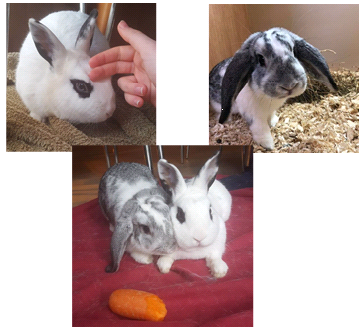
Cleopatra and Cupid are still having lots of cuddles and treats!

Maths
Log into Times Tables Rockstars at www.ttrockstars.com/
Your challenges await!
If you need your username and password, ask an adult to email us.

Here’s a table for you to complete each week. I would like to challenge yourself to complete a times table grid each day and submit your score. Let’s keep track of your progress each week. Your challenge is to beat your last score. Don’t forget, set a 3 minute timer. Once the timer finishes, put your pencil down immediately. Then, mark your answers and add your score out of 100 to the table below.

 | Monday | Tuesday | Wednesday | Thursday | Friday
Score
/100

Monday:

× | 2 | 5 | 3 | 4 | 8 | 6 | 7 | 9 | 11 | 12
10
2
5
3
4
8
6
7
9
11
Tuesday:
× | 2 | 5 | 3 | 4 | 8 | 6 | 7 | 9 | 11 | 12
10
2
5
3
4
8
6
7
9
11

Wednesday
× | 2 | 5 | 3 | 4 | 8 | 6 | 7 | 9 | 11 | 12
10
2
5
3
4
8
6
7
9
11
Thursday:
× | 2 | 5 | 3 | 4 | 8 | 6 | 7 | 9 | 11 | 12
10
2
5
3
4
8
6
7
9
11

Friday:
× | 2 | 5 | 3 | 4 | 8 | 6 | 7 | 9 | 11 | 12
10
2
5
3
4
8
6
7
9
11

Maths:
Task 1:
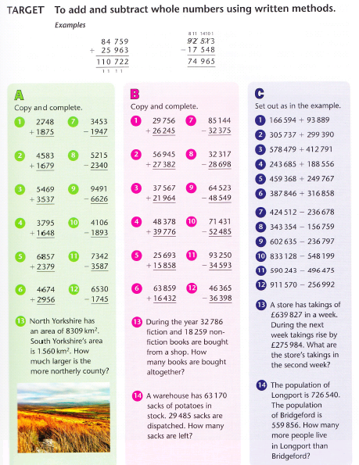

Task 2:
Complete these challenges:
https://www.bbc.co.uk/bitesize/topics/zyhs7p3/articles/z2ndsrd

https://www.bbc.co.uk/bitesize/topics/zfq7hyc

https://www.bbc.co.uk/bitesize/topics/znwj6sg/articles/zxthnbk

https://www.bbc.co.uk/bitesize/topics/zsjqtfr

https://www.bbc.co.uk/bitesize/topics/zy2mn39

https://www.bbc.co.uk/bitesize/topics/z36tyrd

https://www.bbc.co.uk/bitesize/topics/z69k7ty

Extend your home learning:
Create 5 word problems for an adult to complete. The word problems must include addition, subtraction, multiplication or division.

For example:
‘Miss Needham has 50,000 chickens. She sells 23,687 of them. How many chickens does she have left?’

Reading – Mr Jones’ Group
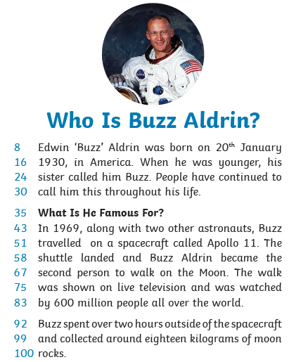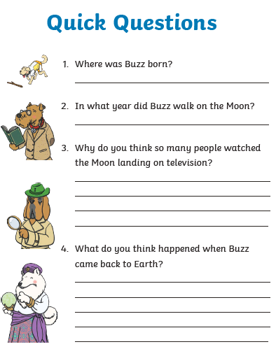

Reading – Miss Needham’s group:
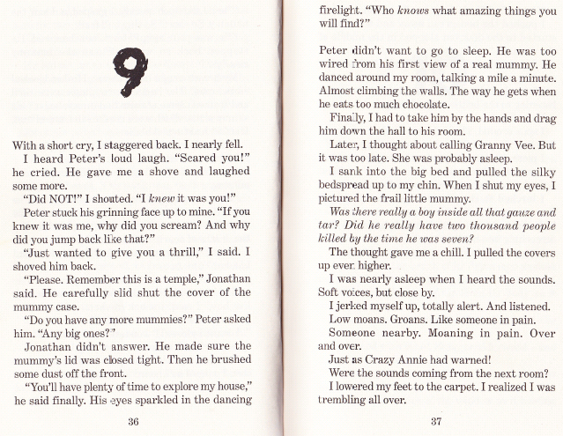
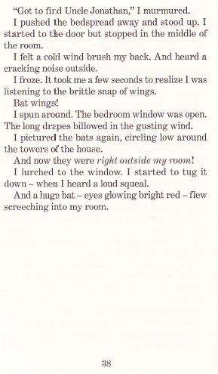
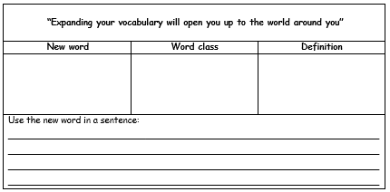

On the next page, you will find a board game! Play the board game with someone in your household! Don’t forget, you might need to explain the story before you play the game!

Instructions:
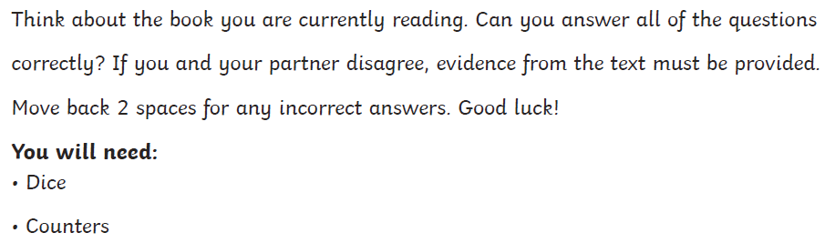

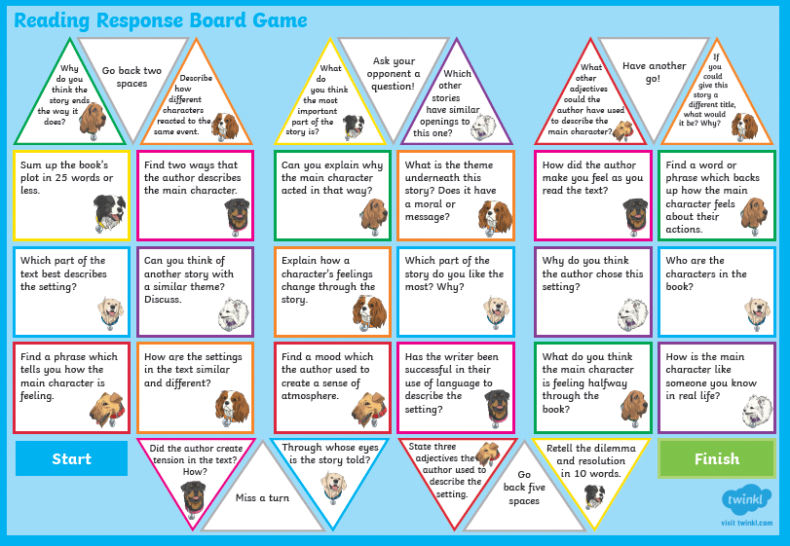
Reading – Mrs James’ group:
On the next page, you will find a board game! Play the board game with someone in your household! Don’t forget, you might need to explain the story before you play the game! You must answer the questions based on what you have read of ‘Street Child’ so far.

Instructions:

Grammar – Mr Jones’ group:
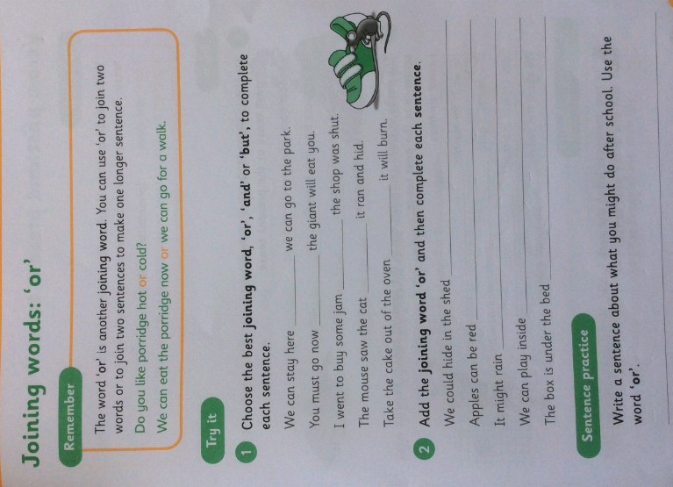

Grammar – Miss Needham’s and Mrs James’ groups:
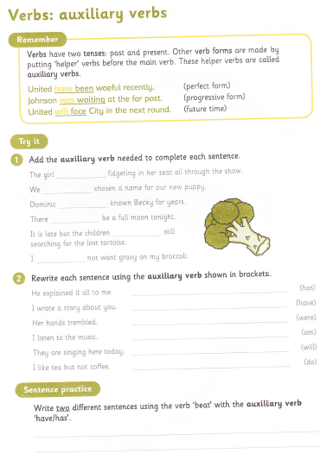
English:
This week we’ll be continuing with digital literacy.
Watch the following short video The Light House
I would like you to retell the story from what you have just watched, don’t worry, you can watch it as many times as you like. Use the traffic lights to push your writing a little more.
Retell the story in your own words using paragraphs to separate the different parts.
Use fronted adverbials for time as you write…..e.g. In the middle of the night.
Use relative clauses beginning with who, which, where, when and whose – e.g. The light house keeper, who was terrified that the ship may crash against the rocks, needed help.
Don’t forget me
You can even type these up as it would great to see what you came up with by sending them to your class teacher.
Extend my English
When you’ve done this why not have a go at writing, or drawing your own short story that’s similar to The Light House.

Art:
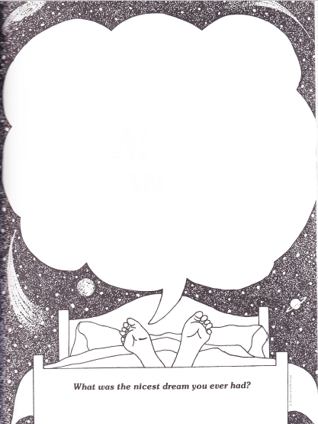
Draw it!

Have a go at this
https://www.youtube.com/watch?v=ZGbcJ318V-8&list=WL&index=2&t=0s
It’s all about school art and hand lettering. I had a go at them and this is where it is at!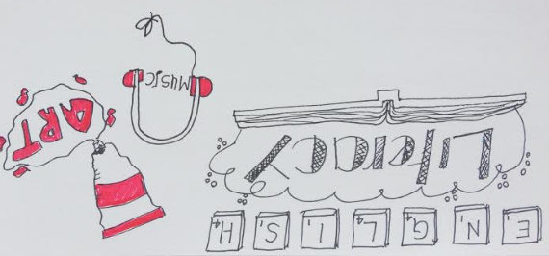

Science
This week we are going to create a sundial. These have been used for centuries and although nobody is really sure where they originate, some people argue Egypt other Greece some now think China, they offer a way to tell the time with the movement of our planet.
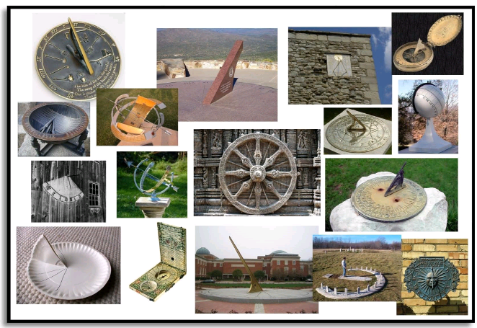
These are some really cool ones but start with the lesson below and build up to these if you are feeling brave.
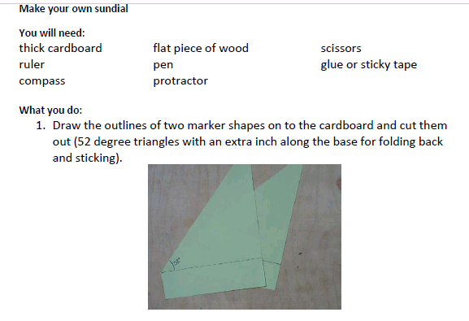
Not got a protractor or a compass?
No worries, here are some free apps
Protractor App (Protractor Angle Measurement)
Compass App (Compass x)

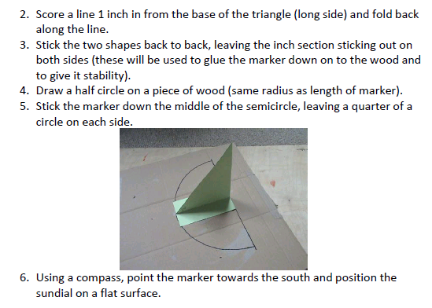

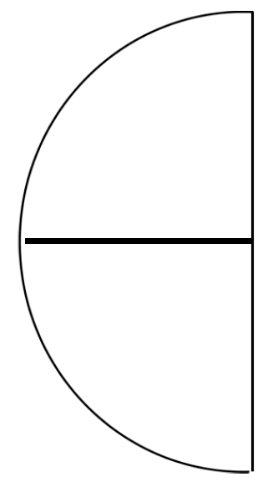

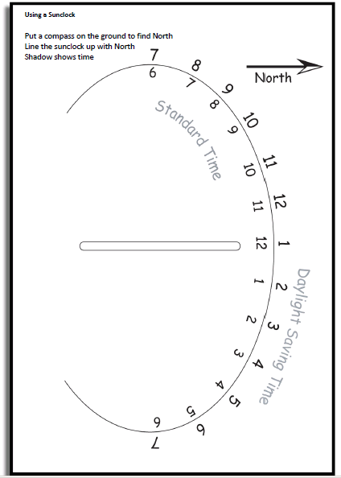

Computing

Hi Year 5 hope you are all well. If you have managed to make your own game and done a little evaluation, here is another type of game you could try!
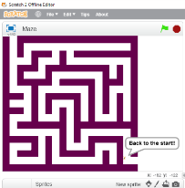

Scratch Maze Games

Import a Maze background Or

Draw a new one – (the walls must all be the same colour)

Set the Sprite to start at the beginning of maze.
- Hover the mouse over the start of the maze
- Write down the coordinates of the start of the maze
X = y =

- Add the following code to move the Sprite to the start of the maze when the Green Flag is clicked
(make sure to put your coordinates in the ‘Go To’ box)

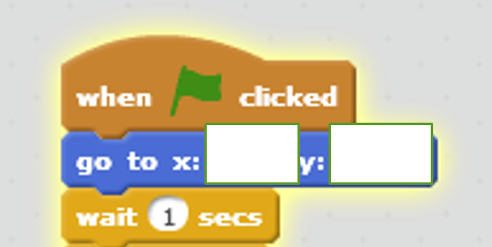

Set the Sprite to follow the mouse
- Add the following code, underneath the existing Scripts

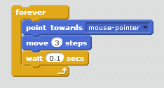

Set an event if the Sprite hits the wall
- Add Scripts to make the Sprite go back to the Start
- And play a sound and display a message
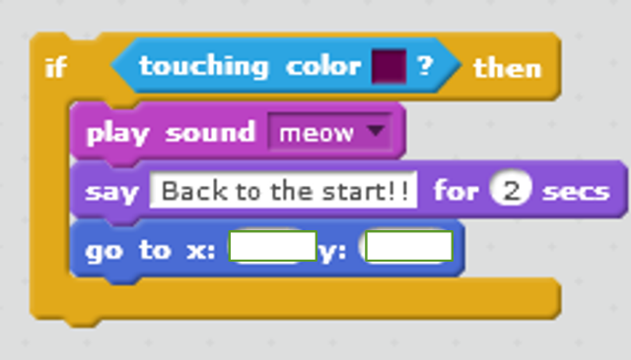

Your completed code should look something like this

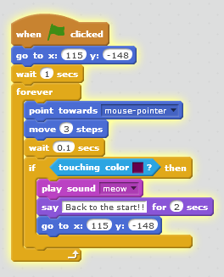

Extensions
Can you control the Sprite also using keyboard?
Can you use a Loop and another costume to make it appear as if your Sprite is walking through the maze?

History
