Comprehension – Week 6
If you are in Miss Derbyshire’s group for English:
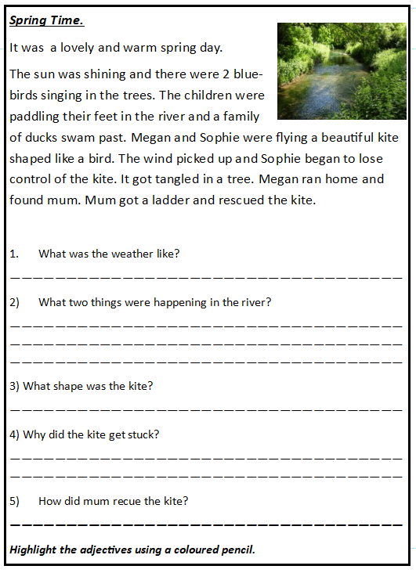
If you are in Mrs Andrew’s group for English:
