Dear Year 1 Starlings and grown-ups,
Below is our second week of Reading and Writing home learning.
Each day is labelled at the top and the activities for that day are below it. You do not need to print these as they can be answered on paper, either the books we gave the children in their pack or any notebooks or paper you have at home.
Each activity:
Word time: this is familiar to the children as we do this everyday as a table top activity. We need to write as many real or alien (nonsense words which don’t make sense) as we can using the sound for that day.
Spelling practise: these are the same words each day, expect for FriYAY as this can be used as their spelling test day. The children need to look at the spelling, say the spelling, cover the spelling, write the spelling then check. Just once for each spelling.
Hold a sentence: again, the children are awesome at this as it is very familiar practise for them in our RWInc, English and afternoon sessions. They need to read the sentence (independently if possible) say it, hold it in their head, write it and then check together. Extra points for capital letters and full stops!
Whoops! Sentence edit: here the children need to edit the sentence writing it out in the correct way. Looking for errors such as capital letters, full stops and finger spaces.
Reading activities: the extracts are taken from RWInc stories and the children should be able to independently read them. If not, they can special friends (these can be found on the RWInc sound mat set 2 and 3 in the resources on the last page), fred talk, read the word. There are sometimes questions to answer about the text.
Writing activities: these differ from using adjectives to writing full sentences about a picture. Again, this can be written in their book or paper.
Resources: on the last page you can find a common exception word mat for year 1 and our RWInc sound mat. These can be made into activities by choosing the words from the common exception word mat and making full sentences. To finding as many items in the house or naming them using a sound from the mat.
Please take your time with these activities and do not feel pressured. There are extra challenges for the children to access also in the orange boxes.
Team Year 1 x
P.S. please find below websites and games which can be used as extra learning:
Phonics play: https://new.phonicsplay.co.uk/ Username: march20 password: home
Twinkl: www.twinkl.co.uk/offer. You can sign up for a free month using a code on the website.
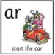
Monday
Word time
Can you write real or alien words using the sound: ar

Spelling practise:
Look, say, cover, write, check!
- there 2. push 3. says 4. be 5. where

Hold a sentence:
Read, say, hold, write, check!
The sun is hot and in the sky.

Reading: with your grown-up or on your own reading out loud, can you read the story?
Remember if it is tricky: special friends, fred talk, read the word.
Tab is a cat. Tab’s just had a kitten! Tab is a great mum. The kitten is called Ben. He has soft fur and blue eyes and looks just like Tab! Meg gives them both their dinner fish for Tab and cold milk for Ben.
Questions to answer:
- What is Tab’s kitten called?
- What does the kitten look like?
- What does the kitten have for dinner?

Challenge:
Could you write the next part of the story?

Tuesday
Word time
Can you write real or alien words using the sound: or
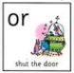

Spelling practise:
Look, say, cover, write, check!
- there 2. push 3. says 4. be 5. where

Whoops! Can you edit the sentences?
- I went to the zoowith my friends

- i can see a monkey

- my can mum see a Fish

Reading: with your grown-up or on your own reading out loud, can you read the story?
Remember if it is tricky: special friends, fred talk, read the word.
Sam’s mum and dad are so busy that they forget to keep their sink clean. Mucky dishes and food sit in the sink. It stinks! And living there is a greedy green gremlin, who loves all the mess! He comes from Green Gremlin Street. He makes his way through the pipes and up the taps, into the sink.

Challenge:
Can you draw what you think the greedy green gremlin looks like?

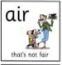
Wednesday
Word time
Can you write real or alien words using the sound: air

Spelling practise:
Look, say, cover, write, check!
- there 2. push 3. says 4. be 5. where

Hold a sentence:
Read, say, hold, write, check!
I want a cat and a rabbit.
Challenge:
Can you underline the conjunction?

Handwriting: can you practise writing the letters?

a b c d e

Reading: with your grown-up or on your own reading out loud, can you read the story?
Remember if it is tricky: special friends, fred talk, read the word.
When I wake up, the street is covered in snow. I love the snow. I can make snow men and snow angels. I wear my hat and scarf. I love to play in the snow.

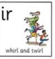
Thursday
Word time
Can you write real or alien words using the sound: ir

Spelling practise:
Look, say, cover, write, check!
- there 2. push 3. says 4. be 5. where

Writing:
Can you write a sentence about each picture and what the characters are doing? Remember to use capital letters, full stops and it must make sense.
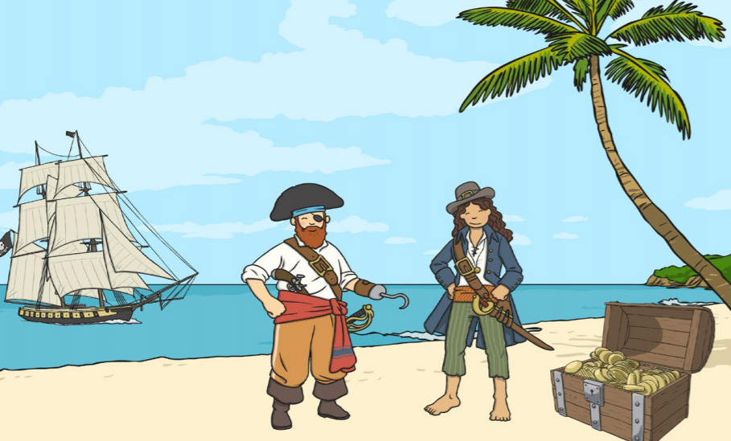
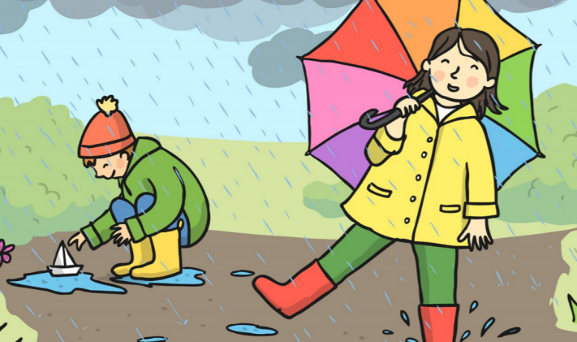

Challenge:
Can you use adjectives to describe what the setting looks like?

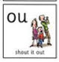
FriYAY
Word time
Can you write real or alien words using the sound: ou

Spelling test:
As it is FriYAY and you have been practising your spellings all week, it is time for you spelling test. Ask a grown up or your brother or sister to test you. Remember just do your best!

- there 2. push 3. says 4. be 5. where

Hold a sentence:
Read, say, hold, write, check!
Can I play with you?

Writing: adjective SPLAT
Can you say or write as many adjectives as you can to describe the superhero? How they look, their feelings or their personality?
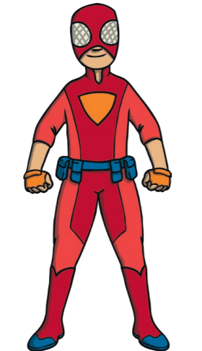
Kind, mighty, brave, red

Challenge:
Using your adjective SPLAT, can you describe the superhero in full sentences?
Resources:
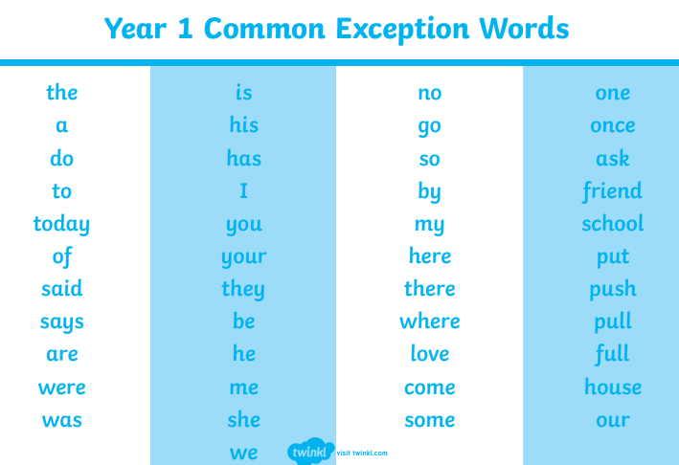
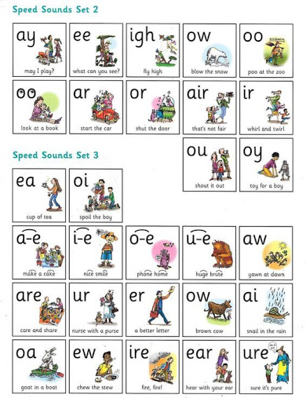
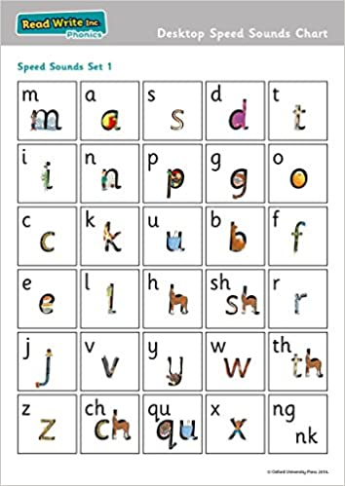
Here are the Year 1 common exception words and Read, Write, Inc sound mat we use in class.

