Hello Y5 Harriers and Kestrels!
We hope you are staying safe and washing your hands regularly. We cannot wait to be back at school with you all.
Here’s some home learning, to complete this week, to keep yourselves busy! Please make sure you put lots of effort into the work, in order to keep up your fantastic progression!

Maths
These maths questions are all based on subtraction!
Don’t forget, start on the colour you feel most comfortable and then challenge yourself!
The order is: blue, red, orange, green and then purple (next step for depth = black)

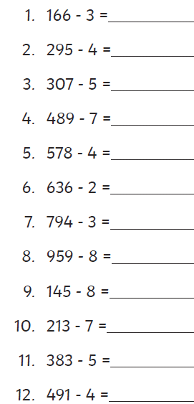

Challenge: Create 5 questions of your own

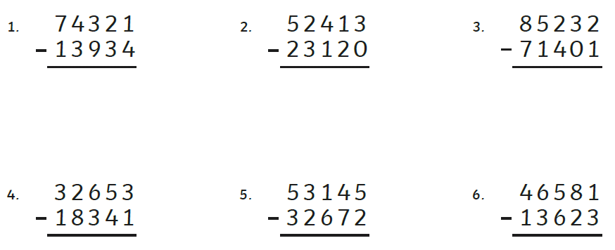

Ch: Round each answer to the nearest 100.

Miss Needham has solved this
equation. Is her answer correct?
Explain your answer.
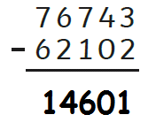

Challenge: Find the correct answer
And then add 4958 to it.

Fill in the missing numbers:
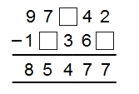
1 mark

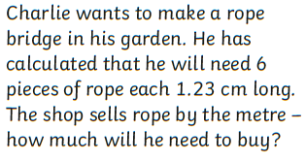

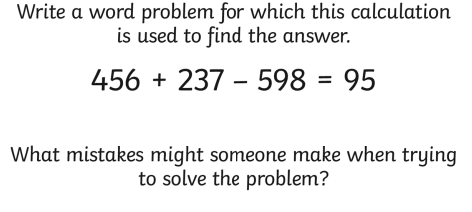

Extra maths challenges:

Follow these links for some extra maths challenges!

https://www.topmarks.co.uk/maths-games/daily10

https://mathsframe.co.uk/en/resources/resource/289/KS2_Maths_Invaders

http://flash.topmarks.co.uk/5305

Log into Times Tables Rockstars at www.ttrockstars.com/
Your challenges await!
If you need your username and password, ask an adult to email us.

Here’s a table for you to complete each week. I would like to to challenge yourself to complete a times table grid each day and submit your score. Let’s keep track of your progress each week. Your challenge is to beat your last score. Don’t forget, set a 3 minute timer. Once the timer finishes, put your pencil down immediately. Then, mark your answers and add your score out of 100 to the table below.

 | Monday | Tuesday | Wednesday | Thursday | Friday
Score
/100

Monday:

× | 2 | 5 | 3 | 4 | 8 | 6 | 7 | 9 | 11 | 12
10
2
5
3
4
8
6
7
9
11

Tuesday:
× | 2 | 5 | 3 | 4 | 8 | 6 | 7 | 9 | 11 | 12
10
2
5
3
4
8
6
7
9
11
Wednesday
× | 2 | 5 | 3 | 4 | 8 | 6 | 7 | 9 | 11 | 12
10
2
5
3
4
8
6
7
9
11

Thursday:
× | 2 | 5 | 3 | 4 | 8 | 6 | 7 | 9 | 11 | 12
10
2
5
3
4
8
6
7
9
11

Friday:
× | 2 | 5 | 3 | 4 | 8 | 6 | 7 | 9 | 11 | 12
10
2
5
3
4
8
6
7
9
11

English

As you know the Titanic was sunk by an iceberg. I would like you to write a report all about icebergs.
They are amazing things and they have a huge impact on their environment so you’ll find a great deal of information online about them.
To start you off I have put a few sites for you to look at and, on the next page, is a template to plan out your report. When you’ve done this you can then write it neatly in your home learning book.

https://www.youtube.com/watch?v=-PPGe7MU6ME
https://kids.kiddle.co/Iceberg
https://nsidc.org/cryosphere/quickfacts/icebergs.html

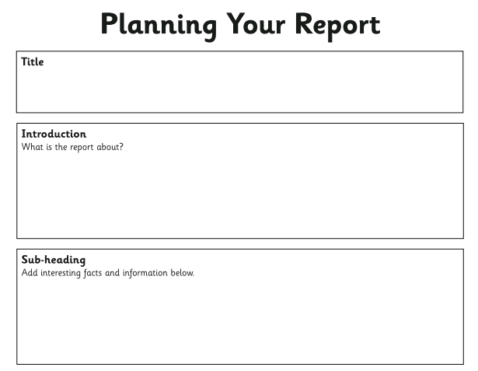
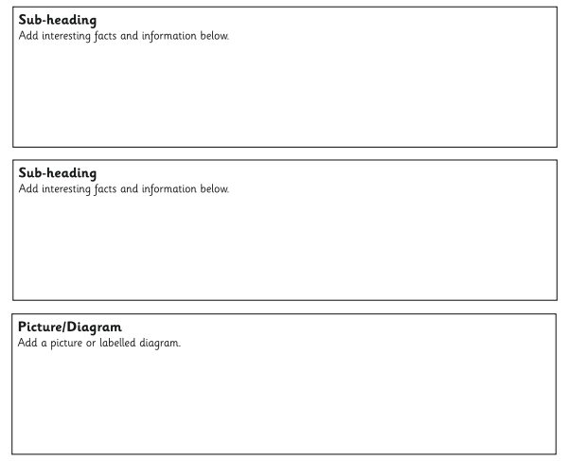

Grammar
Mr Jones’ group:

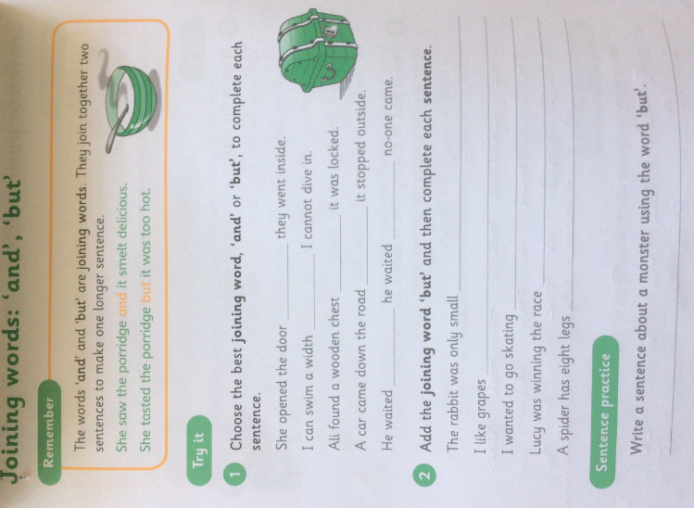

Grammar for Miss Needham and Mrs James’ groups:

Previously, we have learnt what fronted adverbials are and how to use them.
Here’s a reminder:
A fronted adverbial is a word or phrase (group of words) placed at the beginning on a sentence to give more information about the action in the main clause. A fronted adverbial can tell you, when, how, why or where something happened.
For example: In the morning, Rachel brushed her teeth. (This fronted adverbial tells you ‘when’ Rachel brushed her teeth)

Q1. Insert one comma in the correct place in the sentence below.

Every night Dad and my brother take the dog for a walk.
1 mark

Q2. Insert one comma in the correct place in the sentence below.

Limping slightly the old man walked to the end of the road.
1 mark

Q3. Which sentence has been punctuated correctly?

Tick one.
Immediately after, dinner we did the washing up.
Immediately after dinner we did, the washing up.
Immediately after dinner, we did the washing up.
Immediately, after dinner we did the washing up.
1 mark

Reading
Mr Jones’ group:

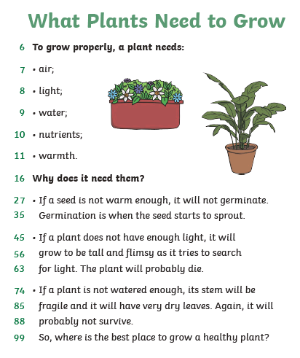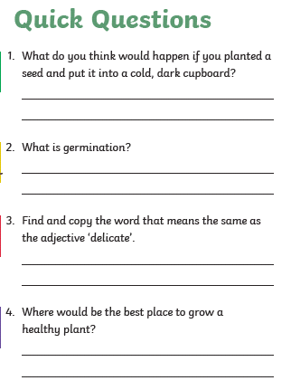

Don’t forget to take a look at https://stories.audible.com/start-listen
You can listen to a wide range of audio books for free here.

Reading:
Miss Needham and Mrs James’ groups:
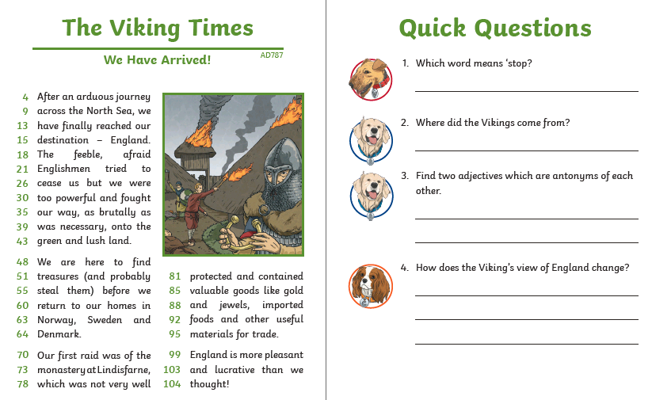

History
Watch this video about children working in coal mines during the Victorian period.
https://www.bbc.co.uk/bitesize/clips/z73b4wx

As you watch, make a list of the jobs children did in the coal mines.
Then, answer these questions:
How dangerous was it for children in the mines?
Why do you think children worked in coal mines?
Challenge: How essential were children to the smooth running of the coal mines?

Science
We have been looking at life cycles last week and we are going to have a look at mammals this week and their habitats.
Mammals live in a variety of different habitats and, after watching this video https://www.youtube.com/watch?v=kACaok7DRlM
I would like you to chose four animals and write a paragraph about the habitat they live in
I have included some key words here to help your learning.
forest tree hot cold wet family
safe food source warm arid community luscious

.
Music
You have two options this week. You can try one or both to see which one you like.
1. Use https://www.onlinepianist.com/virtual-piano to compose your own 30 second piece of music

2. Listen to a piece of music from a video game and describe how this tries to make the player feel.

Spanish
As we are all indoors at the minute this is a quiz all bout different things in your house. https://quizlet.com/215993805/la-casa-diagram/
There are 18 to try and learn and then you can ask a grown up to test you or even just start using that word instead of the English word to be really fancy about it.

Computing….This is a continuing project
To plan and create an interactive game.
You could try using scratch https://scratch.mit.edu/.
But if you a different idea as long as the task is completed go for it!
Here is an example:
https://scratch.mit.edu/projects/381893990/
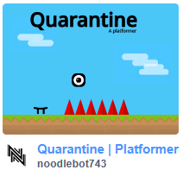
This task should take a few weeks, you don’t need to do it in one week or all in one day!!
Remember to keep safe yourself and stay healthy no longer than 40 minutes on a computer without a rest for your eyes.

Art
One of my favourite artists is Edward Hopper. He was an American artist and painted simple pictures usually with one or two people in. Take a picture, in his style on a phone or tablet and try and copy what he did. You don’t need to colour it in or paint it, black and white is just fine.

Just for fun
https://www.wizardingworld.com/collections/harry-potter-at-home
This is all about Harry Potter and home learning. It is so good.

