Spr 2



Pack 2 – Complete as many of these activities you can.

|  |  |
| --- | --- |
| **Activity** | **Tick and sign if completed** |
| Make an Easter card for someone |  |
| Plant some tomatoes or beans |  |
| Go on an Easter egg hunt |  |
| Draw pictures of The Easter Story |  |
| Make a 3D chick or rabbit |  |
| Bake some Easter buns |  |
| Count the money in your piggy bank. |  |
| Go on a 3D shape hunt |  |
| Paint a picture of Spring flowers and label them |  |
| Write your own story about ‘The Big Bad Wolf’ |  |
| Tell an Easter joke. Here is my joke…  **How did the wet Easter Bunny dry himself?** With a hare dryer! |  |
| Play a game and tell me who won |  |
| Draw a map of a journey you went on and label it |  |
| Watch a film and then draw and write about it |  |

Also see if you can do any of the Maths and English sheets.

\*Remember neat writing, correct formation of letters and correct spellings are important.

Which of the numbers can you partition?

|  |
| --- |
| = 7  +  = 7  +  = 7  +  = 7  + |
| = 10  = 10  +  +  = 10  = 10  +  + |
| = 13  = 13  +  +  = 13  = 13  +  + |
| = 16  = 16  +  +  = 16  = 16  +  + |

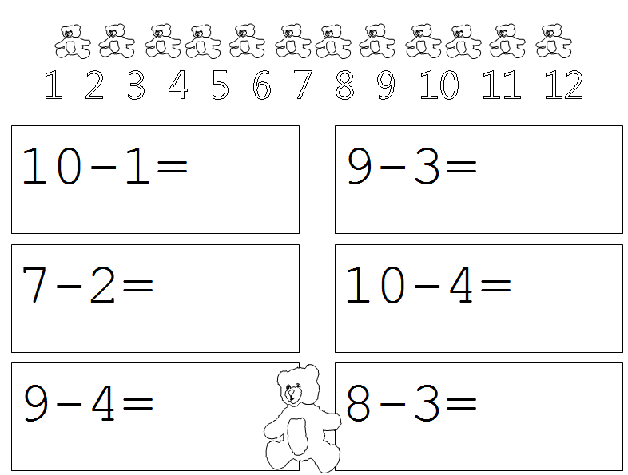

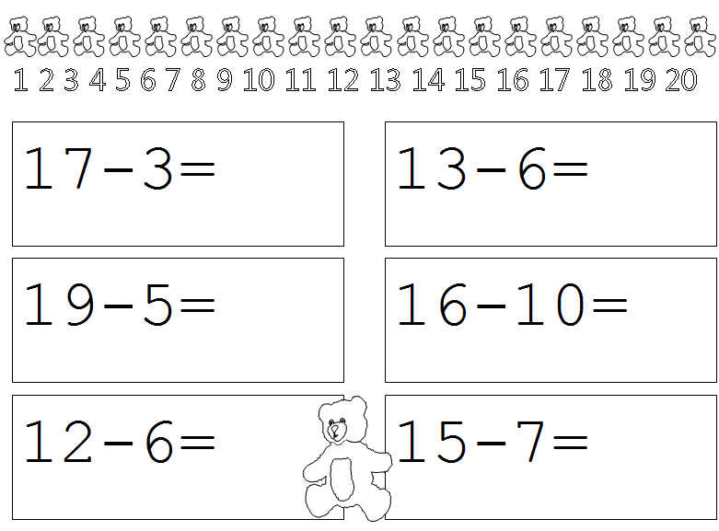

Now try your own add and take away.

**Mixed CVC Words: Middle a,e,i,o,u**

Write the words to go with each picture.

|  |  |  |
| --- | --- | --- |
| MCj02151770000[1]  \_\_\_\_ \_\_\_\_ \_\_\_\_ | MCj01372090000[1]  \_\_\_\_ \_\_\_\_ \_\_\_\_ | MCj03985970000[1]  \_\_\_\_ \_\_\_\_ \_\_\_\_ |
| MCBD09915_0000[1]  \_\_\_\_ \_\_\_\_ \_\_\_\_ | MCAN00627_0000[1]  \_\_\_\_ \_\_\_\_ \_\_\_\_ | MCj02909360000[1]  \_\_\_\_ \_\_\_\_ \_\_\_\_ |
| MCj03226060000[1]  \_\_\_\_ \_\_\_\_ \_\_\_\_ | \_\_\_\_ \_\_\_\_ \_\_\_\_ | MCj02321800000[1]  \_\_\_\_ \_\_\_\_ \_\_\_\_ |

Can you think of any other words with a,e,i,o,u in them?

\_\_\_ a \_\_\_ \_\_\_ e \_\_\_ \_\_\_ i \_\_\_

\_\_\_ o \_\_\_ \_\_\_ u \_\_\_

Spell the CVC words and draw the pictures.

|  |  |  |
| --- | --- | --- |
| MCj02871920000[1]  \_\_\_ \_\_\_ \_\_\_ | l e g | \_\_\_ \_\_\_ \_\_\_ |
| MCj01361890000[1]  \_\_\_ \_\_\_ \_\_\_ | h u t | m a n |
| t e n | MCj02904180000[1]  \_\_\_ \_\_\_ \_\_\_ | MCj02395470000[1]  \_\_\_ \_\_\_ \_\_\_ |

Now use these words to write sentences.

Remember full stop, finger spaces and capital letters!

Read and match sentences to the pictures

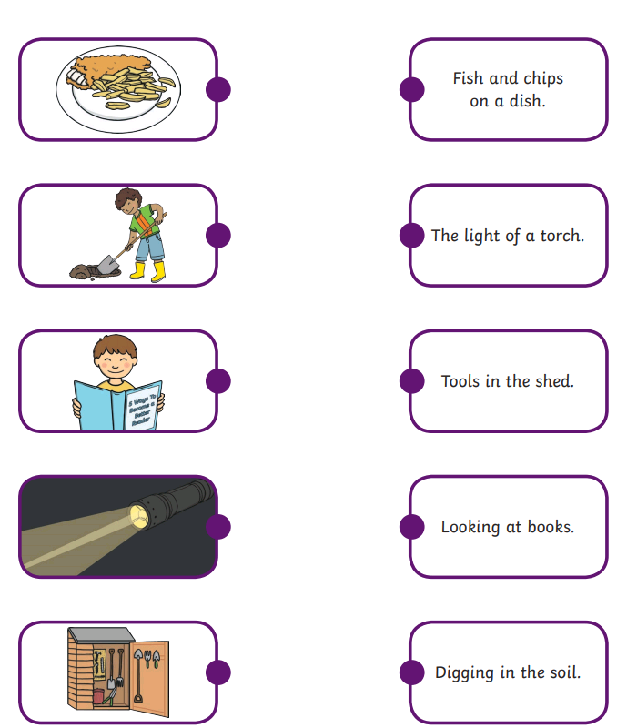

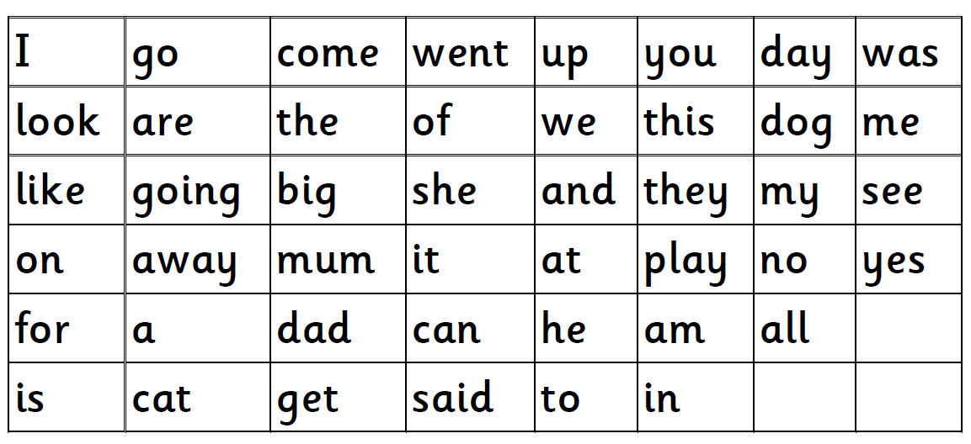

Which words can you read and spell?

Colour the word in yellow if you can read it.

Then colour over it in blue if you can spell it.

Good luck!!

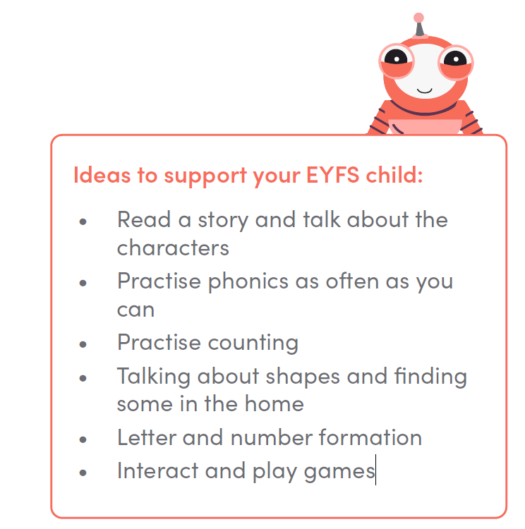

Websites that might be useful during your time at home

You can play games online or simply download things:

1. <https://home.oxfordowl.co.uk/>
2. <https://www.tts-group.co.uk/home+learning+activities.html>
3. <https://www.twinklco.uk/>