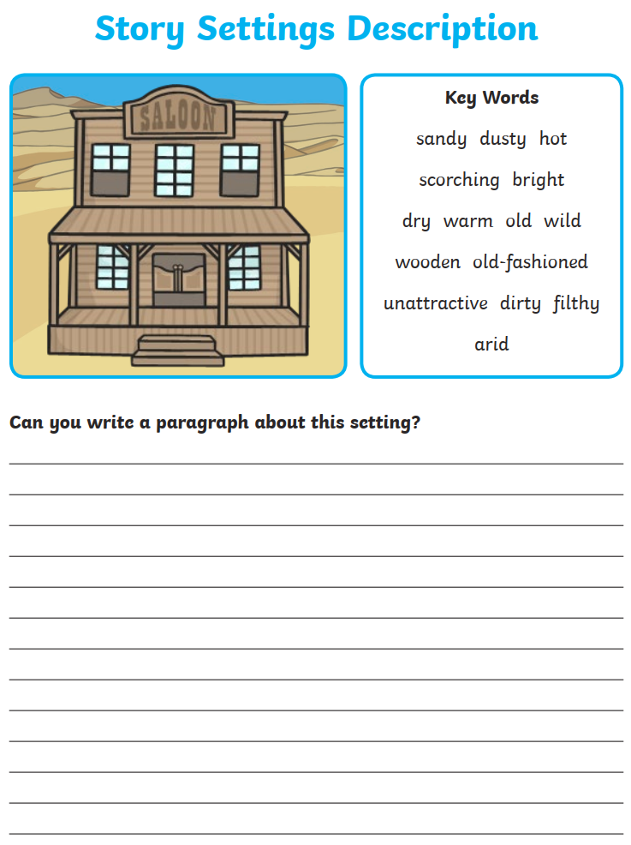

**Descriptive writing piece**

**Write a descriptive paragraph using the picture below. Describe the building, the people you might see here, the smells, sounds, weather; bonus points for using similes, metaphors, etc! 😊**