1) 41 + 25 =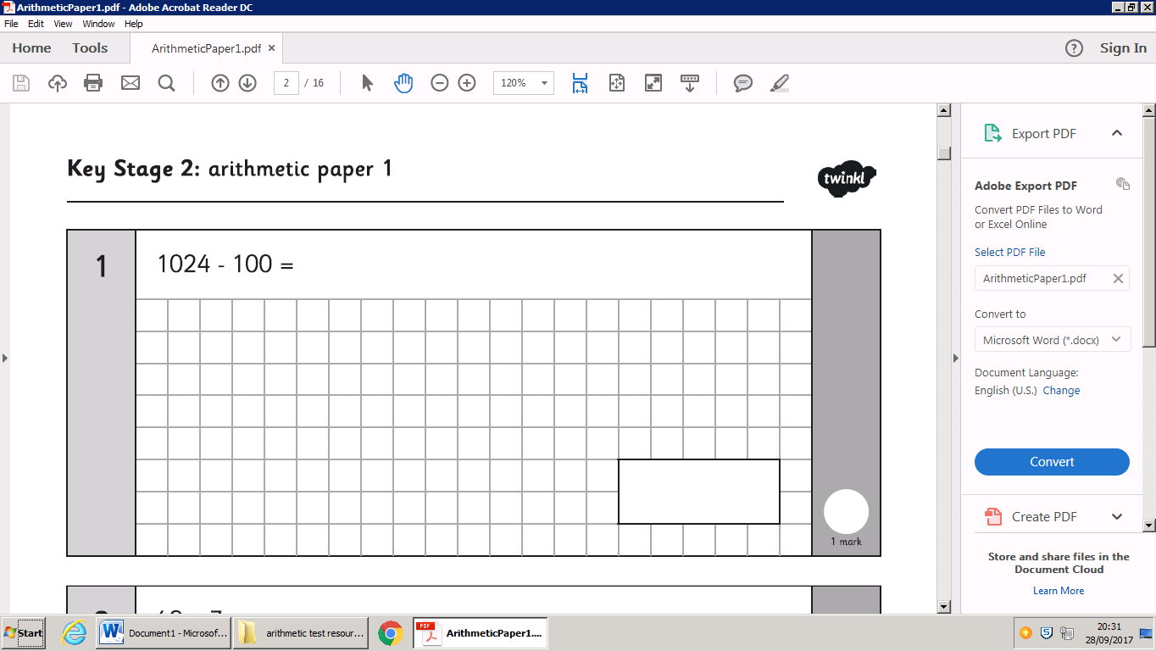

2) 98 - 26 = 

3) ___ = 32 + 54 

4) 65 + 29 = 

5) 28 + 77 = 

6) 92 - 63 = 

7) 37 + 29 = 

8)  91 – 67 =

9) 93 - 68 ==

Can you write all the fact families for the numbers 80,10 and 8?

Can you write all the fact families for the numbers 14,47 and 33?