SEND Information Report

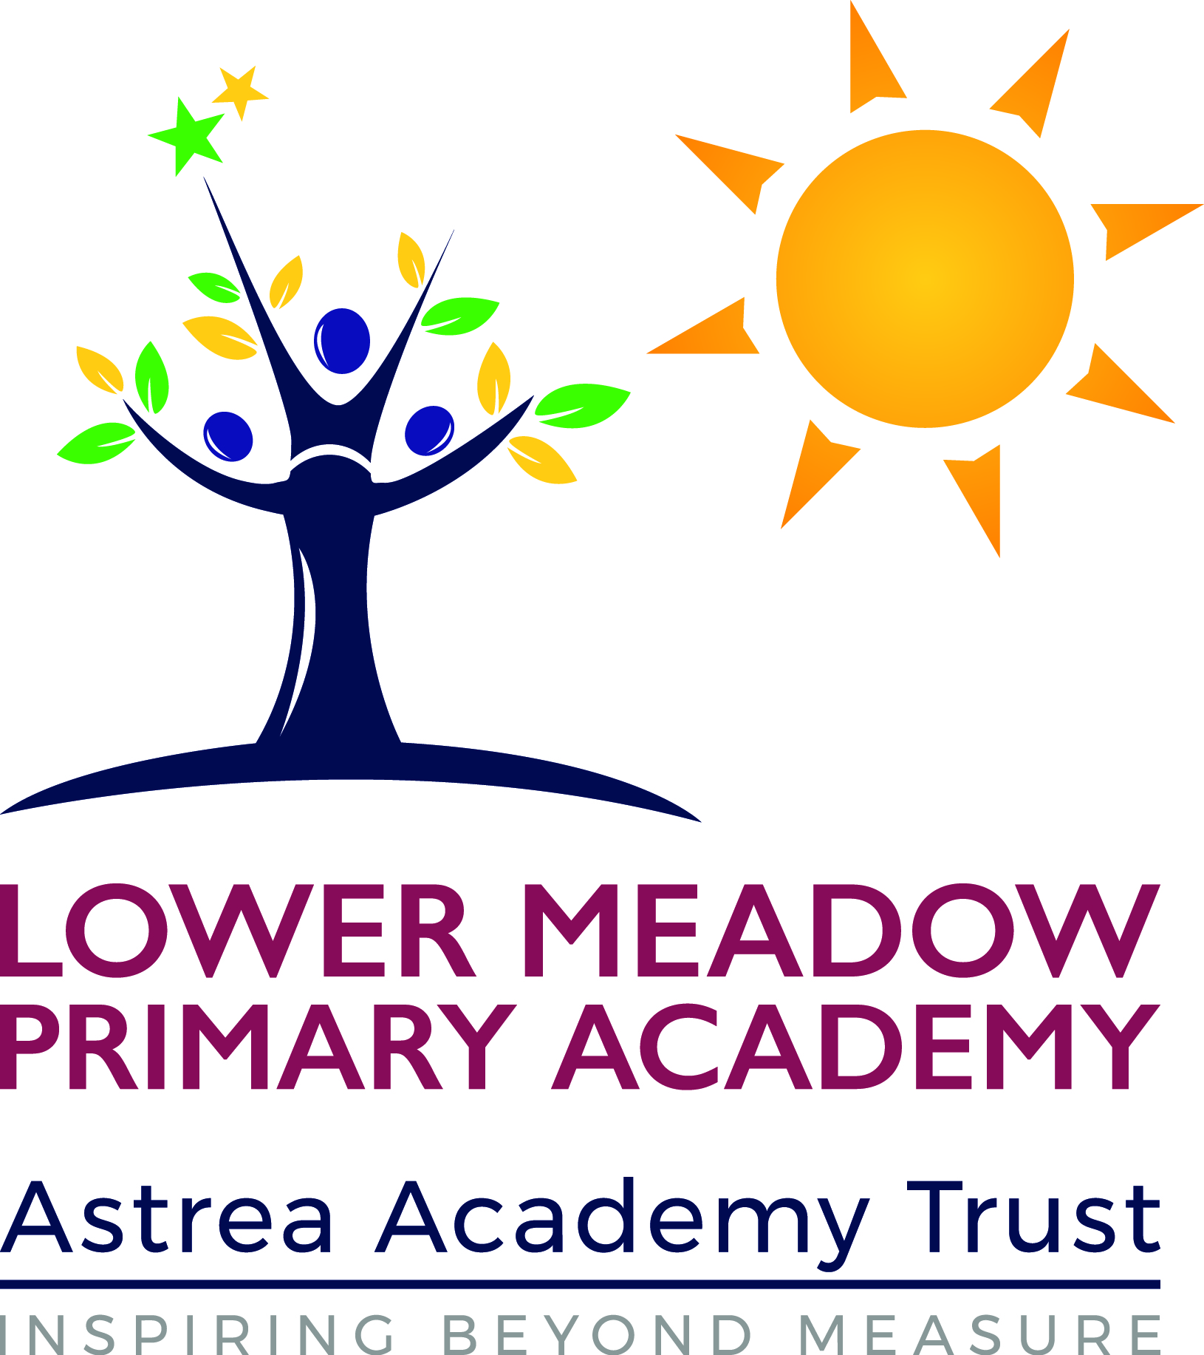

Policy Agreed: April 2019

Policy Review: April 2020

Lower Meadow Primary Academy is part of the Astrea Academy Trust. We are a mainstream primary school and we admit pupils from age 4 to 11. Nursery provision is also available from the term in which pupils are 3.

1  What kind of Special Educational Needs are provided for at Lower Meadow? | At Lower Meadow we provide support for pupils across the 4 areas of need as laid out in the SEND Code of Practice 2014 :  - Communication and interaction  - Cognition and learning  - Social, emotional and mental health difficulties  - Sensory and/or physical needs  At Lower Meadow, we have an IR for hearing impaired pupils where BSL is used to communicate.
2  How do you ensure children who need extra help are identified early? | Pupils are identified as having SEND, and their needs assessed, through :  - information passed on from other Nurseries and previous primary schools;  - end of Key stage results and progress data;  - feedback from teaching staff and observations;  - referrals/concerns from parent/carers;  - SEND concern forms are used by teachers to flag up concerns about progress or ask for extra support from the SENCO;  - speech and language screening in Nursery.  Specialist assessments can be carried out by the SENCO, Learning Support, Speech and Language and the Educational Psychologist.
3a  How do you judge whether the support has had an impact? | - Progress meetings are held after each data point and individual children are discussed and their progress evaluated.  - Interventions are tracked at the start and the end to monitor how effective they are.  - Reports are made to the Governing Body at least annually.
3b  What arrangements do you have for assessing and reviewing pupils’ progress? | At Lower Meadow we:  - track data each half term and hold pupil progress meetings with teachers to review individual progress;  - hold SEND reviews three times a year;  - complete annual reviews for children with Education, Health, Care (EHC) plans or Statements;  - hold reviews 3 times a year for children with a My Plan;  - hold regular parent evenings.
3c  How do you teach children with SEND? | Provision for SEN pupils includes :  - “Quality First Teaching”, with appropriate differentiation in place;  - extra adult support in classrooms;  - personalised provision through time limited interventions;  - personalised provision through the use of resources and specific teaching strategies;  - a school funded KS2 SEND group providing small group support for children with very complex difficulties.
3d  How do you adapt the curriculum and learning environment for pupils’ with SEND? | At Lower Meadow provision includes:  - different strategies used in the classroom setting;  - small group teaching that targets specific levels of progress;  - differentiated resources and teaching styles;  - appropriate choices of texts and topics to suit the learner;  - access arrangements for tests and or examinations;  - additional adult (TA) support:  - links with outside (alternative) provisions.
3e  How accessible is your school environment? | - Rooms used by pupils are all on one level (ground floor)  - Disabled toilet facilities.  - Classes use visual resources such as visual timetables.  - Staff throughout the school use basic BSL which they use to support language development.  - Communicate in Print is used throughout the school to support children.  - Training is arranged from specialist teams to support learners with medical needs such as Peg feeding and allergies (Epipen).
3f  How do you support the development of good social, emotional and mental health for children with SEND? | At Lower Meadow we offer:  - An anti-bullying policy that is supported by annual anti-bullying weeks.  - Teaching Assistants trained in interventions such as ‘Happy to be me’ and ‘Circle of Friends’.  - Pupil Voice via the School council.  - Specialist support from the MAST (Multi Agency Support) team, CAMHS and the Educational Psychologist.  - A Safeguarding Officer who provides a strong link between parent/carers and school.  - Care plans for children with long term medical needs are written and reviewed annually.  - A member of the safeguarding/inclusion team attends Team around the Child/Family meetings arranged by MAST.  - Interventions to support specific needs are run by Teaching Assistants.
How are children with SEND enabled to engage in activities within school? | - Individual risk assessments are written to enable children to attend school trips and visits. Support required will be identified and arranged in these risk assessments.  - The Inclusion Team ensure that children with social and emotional difficulties and medical needs have access to after school clubs and our breakfast club.
4  Who is your SEND Co-ordinator? | Our SEND co-ordinator is:  Sara Bamford (Deputy Head)  0114 2372700  sara.bamford@astrealowermeadow.org  Parent/Carers with safeguarding concerns should contact a member of our safeguarding team – Luke Short (DSL) and Sara Bamford (DSD)
5  What training have the staff supporting children with SEND had, or are currently having? | - HI staff are trained in BSL and all staff have some basic BSL signing which they use to support language development.  - Staff in different areas of the school have been trained by the Speech and Language team to deliver specific language programmes.  TA’s have accessed training in the following areas:  - Use of Numicon to support maths  - Dyslexia  - Delivery of interventions such as ‘Happy to be Me’ and ‘Circle of Friends’  - Lego Therapy  - Specific language interventions such as LEAP, NIP and VIP.  - Speed Up  - Read Write Inc and Freshstart  - Nurture principles  - Team Teach training is on a rolling programme for key staff  - Shape coding  - Lower Meadow acknowledges that at times we need specialist advice and we buy in support from external agencies such as the Educational Psychology Service and the Speech and Language Team.  - We also work closely with agencies such as MAST and the Autism Service.  Training for medical needs within school is updated annually or as needed. Staff are currently trained to support:  - Allergies (epipens)  - Peg feeding.
6  How will equipment and resources be secured? | - SEND Allocation Funding  - Pupil Premium Funding  - Charities  - Support Services
7  How are parent/carers involved? | Lower Meadow is committed to building strong working relationships with parent/carers. We do this in a variety of ways including:  - Newsletters  - Attendance newsletters  - Texts about key events  - Coffee mornings  - Parent/Carer workshops  - Parent evenings  - Celebration assemblies  - Termly SEND reviews  - Annual reviews for children with EHC plans/statements of educational need  - Stay and Play sessions in Nursery  - Carers of looked after children (LAC) have regular reviews meetings led by the LAC Co-ordinator (Sara Bamford). The progress of these children is monitored carefully.
8  How can my child give his/her views about their education? | - School council  - One Page Profile reviews  - Annual reviews  - Children’s views are also asked as part of our lesson review process  - Questionnaires
9  How are complaints dealt with? | See complaints procedure
10  How are the Governors involved and what are their responsibilities? | - The SENCO contributes information when requested which is presented at the Governors meetings. Reports give information regarding the progress of children with SEND but do not refer to individuals so that confidentiality is maintained.  - We have a designated SEND governor: Fiona Vallely.
11  What specialist services are available to the school? | - We work closely with outside agencies such as Ryegate, the Nursing Team, MAST, CAMHS, the Autism Service, the Hearing Impaired Service and Social Care. In Early Years we also have access to support from the Early Years Inclusion Team.  - Lower Meadow works closely with Primary Inclusion and the SEND Team.
12  How do you support pupils’ with SEND in transition? | At Lower Meadow we support transition in a variety of ways including:  - Inductions for children starting in our nursery.  - Inductions with key staff for pupils’ transferring to us mid term.  - Social stories are used to support children with SEND as they move to a new year group.  - Transition days are planned to allow children to get to know their new teachers. Extra visits are planned for children with SEND.  - Transition visits with secondary schools and meetings between key staff.  - Prompt transfer of information – all information relating to Child Protection and SEND is passed on to the new school quickly.  - The views of the child are recorded in One Page Profile reviews and these are passed to the next teacher. The One Page Profiles include strategies that work for each child as well as their strengths and areas of need.  - Ambitions and strengths are recorded in Annual EHCP reviews and the SEND Team works with the school to help the child achieve these in the long term.
13  Where is our SEND policy? | Our SEND policy can be found on our website.
14  Where is your “Local Offer” published? | From 1st September 2014, the “Sheffield Local Offer” is available on their website www.sheffield.gov.uk There is also a link on the website.

