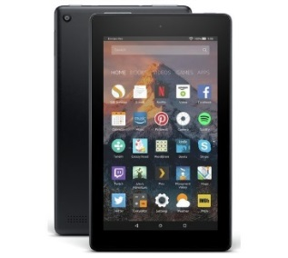
Pupil Premium
Win a Kindle Fire 7 !!!
Help us to get extra funding for your school by completing the attached form.
All completed forms will be placed in a draw with the chance to win a Kindle Fire 7!
We are trying to identify those parents who would previously been entitled to Free School Meals as well as the additional Pupil Premium funding for the school to claim free meals due to being in receipt of certain benefits.
Whilst we are trying to encourage children to be healthy and eat a nutritional school lunch this is optional and you can register your child’s entitlement for the Pupil Premium funding regardless of whether or not your child takes up any entitlement to a Free School Meal.
Your child could be entitled to Free School Meals by registering and up to £1900 of additional funding for the school. This additional funding is typically used towards targeted learning support, enhancing the curriculum offer within school, subsidised educational visits and activities within school.
If you are in receipt of the below benefits and/or any of the below statements apply to your family, then please fill in the form and/or speak confidentially to someone in the school office by Wednesday 17th January 2018.
Eligibility Checklist:
- Income Support
- Income-based Jobseekers Allowance
- Income-related Employment and Support Allowance
- Support from NASS (National Asylum Support Service) under part 6 of the Immigration and Asylum Act 1999
- The guarantee element of State Pension Credit
- Child Tax Credit (with no Working Tax Credit) with an annual income of no more than £16,190
- Working Tax Credit run-on
- Universal Credit
- I am the parent of a child who I have adopted from care
- I am the parent of a child who lives with me under a Special Guardianship Order made on or after 30th December 2005
- I am the parent of a child who lives with me under a Residence Order on or after 14th October 1991
Please complete and return to the school office by Wednesday 17th January, you will be entered into a free prize draw to win a Kindle Fire 7!
Child's First Name | Child's Last Name | D.O.B

Please place an X in this box if you are not sure whether your joint family income is over £16,190 or whether you are in receipt of one of the benefits listed , but you would still like us to check if your child is eligible for Pupil Premium.
Parent/Carer Details – Please complete ALL boxes.
 | Parent/Carer 1 |  | Parent/Carer 2
Last Name
First Name
D.O.B
National Insurance No
Telephone Number
Address | Postcode: |  | Postcode:
Thankyou for completing this form to ensure your child’s school is as well funded as possible
Declaration: The information I have given on this form is complete and accurate. I understand that my personal information is held securely and will be used only for Local Authority purposes. I agree to the Local Authority using this information to process my application for pupil premium. I also agree to notify the Local Authority if there is any change in my family’s financial circumstances as set out in this form.
Signature of Parent/Carer: _____________________________________________ Date: ________________

