Create puppets to retell the story of the three little pigs.  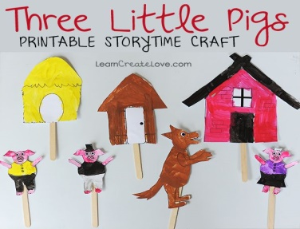 | Create a witches house using 2D and 3D shapes.  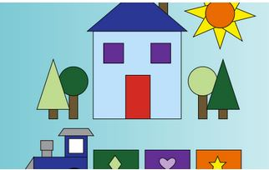 | Create a miniature magical door for your bedroom at home. What exciting adventures happen behind the door. Come and tell us a school.  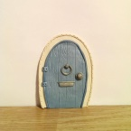 | Learn to count forwards and backwards in 10’s.  10,20,30,40….  90,80,70…..  Can you use different characters’ voices?
Read at home and bring in your favourite fairy tale book.  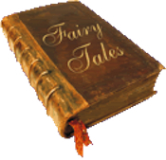 | Learn your doubles to 10.  1+1=2  2+2=4  3+3=6  4+4=8  5+5=10  How quickly can you say them? | If you had a house made of sweets what would it be made from? Write a list | Make your own three little pigs.  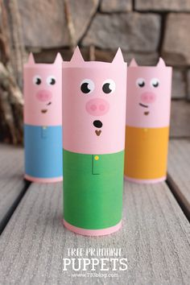
Make a story map to retell the story of hansel and Gretel  .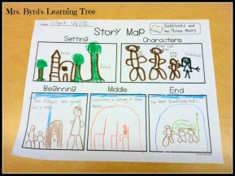 | Create your own characters using story stones.  Write a story.  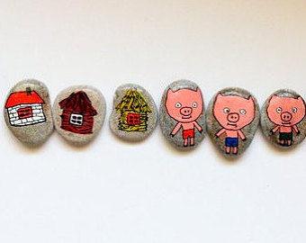 | Design and make your own witches house from the story Hansel and Gretel.  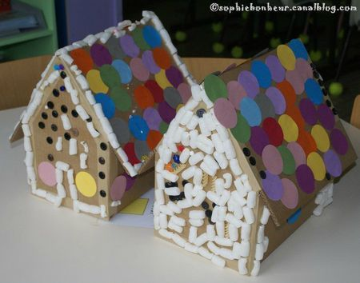 | Make a list for the three little pigs of the materials you can find in your home.  What words would you use to describe them?  e.g. Shiny foil, cold metal, rough/smooth/soft/hard

